
Takeover of the Leeds SEND and AP Improvement Board
November 2025

Opening
On Tuesday 25th November 2025, 33 students from Future Steps Broomfield, Powerhouse West SILC, Pivot Academy, Green Meadows Academy, The Bridge East SILC, John Jamieson East SILC, Penny Field school and Enterprise and Employability Leeds City College took over the Leeds Area SEND and AP Partnership Board as part of national takeover challenge.

The aim of the takeover was to:
- Learn about each other.
- Learn about the issues that are important to young people with SEND.
- Agree how services will work with students to tackle the issues raised.

Obligation
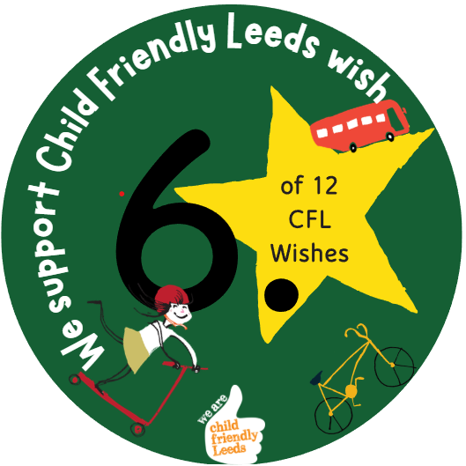

We support Child Friendly Leeds wish

Opportunity
Students from The Bridge, East SILC shared with the board their suggestions and ideas for improving home to school transport.

Actions agreed at the Takeover in November 2025:

- Review routes.
- Drives to dress up at Christmas.
- Speak to drivers about roles.
Outcome
The Passenger Transport Team reviewed the route planning for journeys.

The service actively encourages drivers to dress up for Red Nose Day and Xmas.

All Drivers and PA’s receive support via their Appraisals around their role as a driver.

Refresher training to all PA’s and Drivers is via a rolling programme.

