
Takeover of the Leeds SEND and AP Improvement Board
November 2025

Opening
On Tuesday 25th November 2025, 33 students from Future Steps Broomfield, Powerhouse West SILC, Pivot Academy, Green Meadows Academy, The Bridge East SILC, John Jamieson East SILC, Penny Field school and Enterprise and Employability Leeds City College took over the Leeds Area SEND and AP Partnership Board as part of national takeover challenge.

The aim of the takeover was to:
- Learn about each other.
- Learn about the issues that are important to young people with SEND.
- Agree how services will work with students to tackle the issues raised.


Obligation
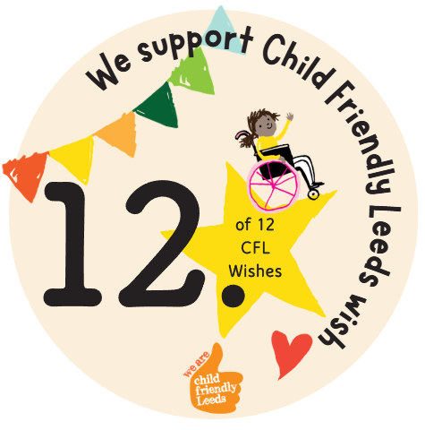

We support Child Friendly Leeds wish

Outcome
The Leeds Local Offer and Child Friendly Leeds Teams have developed and published information about the Sunflower Lanyard that has been added to the Raising Awareness of Disabilities pages on the Leeds Local Offer and Child Friendly Leeds websites.

The information includes
- What is the sunflower lanyard
- Benefits to individuals
- Tips for people who see someone wearing the sunflower lanyard

Opportunity
Students from Pivot Academy shared with the board that there needs to be more awareness of the Sunflower Lanyard.

Actions agreed at the Takeover in November 2025:

- Explore further with students how to raise awareness of the Sunflower Lanyard amongst peers and within the community.


