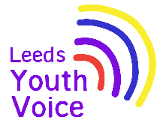
Takeover of the Leeds SEND and AP Improvement Board
November 2025

Opportunity
Students from Future Steps Broomfield shared with the board that there is a lack of safe spaces in Leeds for young people with SEND.

Actions agreed at the Takeover in November 2025:

- Get a baseline of what safe spaces are already out there.

- Work with the school to develop ‘what is a good safe space’, and encourage partners like WYCA , the NHS, council owned destinations, shopping centres and retailers to provide more safe spaces.

- Put together a list of what's available across the city and promote and advertise it in an accessible way.
Outcome
Sensory spaces
Leeds City Museum have a Sensory Nook on temporary loan for a month.

During the month of October 2026, the museum will be consulting with young people and visitors to gather their feedback on the space.

Students from Future Steps Broomfield visited the Nook on the 15th October 2026 and gave their feedback.

Sensory Nook | Leeds Museums and Galleries | Days out and exhibitions

Things to do and places to visit
The Leeds Local Offer team have worked with the SEND Youth Council to develop a Things to do and places to visit booklet that will be launched in October 2026.

The ‘things to do’ section on the Leeds Local Offer website has been reviewed and update. Things to do | Leeds Local Offer

Obligation
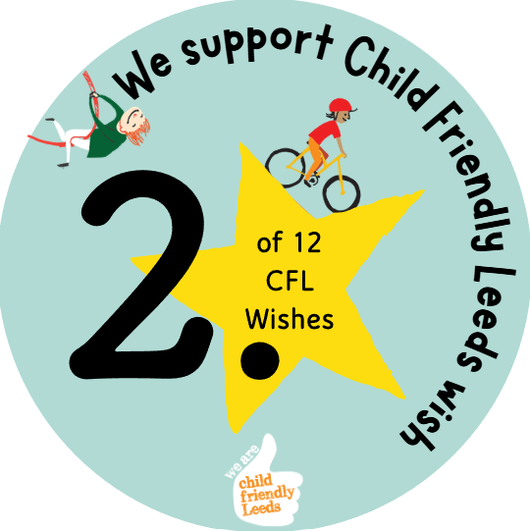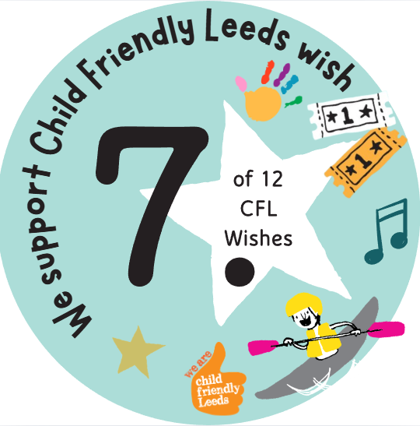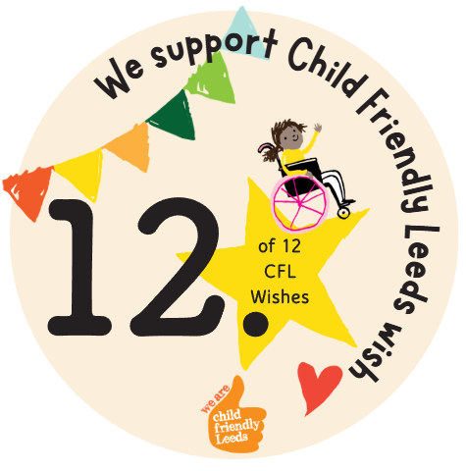

We support Child Friendly Leeds wish

Opening
On Tuesday 25th November 2025, 33 students from Future Steps Broomfield, Powerhouse West SILC, Pivot Academy, Green Meadows Academy, The Bridge East SILC, John Jamieson East SILC, Penny Field school and Enterprise and Employability Leeds City College took over the Leeds Area SEND and AP Partnership Board as part of national takeover challenge.

The aim of the takeover was to:
- Learn about each other.
- Learn about the issues that are important to young people with SEND.
- Agree how services will work with students to tackle the issues raised.

