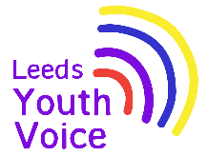
Takeover of the Leeds SEND and AP Improvement Board
November 2025

Opening
On Tuesday 25th November 2025, 33 students from Future Steps Broomfield, Powerhouse West SILC, Pivot Academy, Green Meadows Academy, The Bridge East SILC, John Jamieson East SILC, Penny Field school and Enterprise and Employability Leeds City College took over the Leeds Area SEND and AP Partnership Board as part of national takeover challenge.

The aim of the takeover was to:
- Learn about each other.
- Learn about the issues that are important to young people with SEND.
- Agree how services will work with students to tackle the issues raised.

Obligation
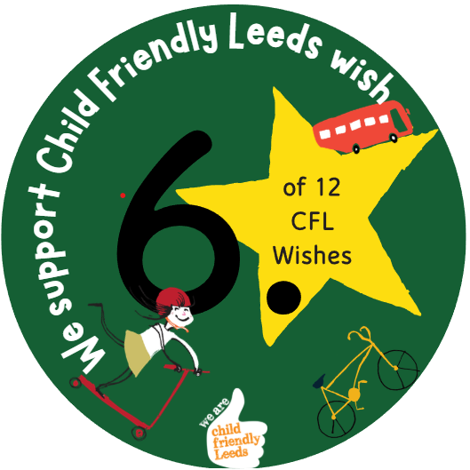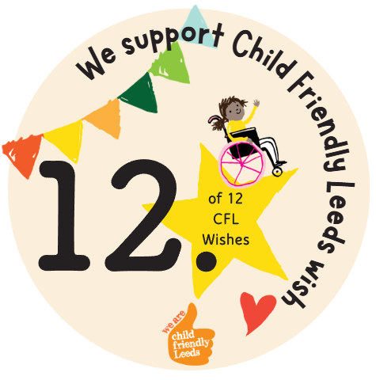

We support Child Friendly Leeds wish

Opportunity
Students from John Jamieson, East SILC shared with the board the need for a pedestrian crossing outside of the school to support independent travel training.

Actions agreed at the Takeover in November 2025:

- Access the location for a pedestrian crossing.


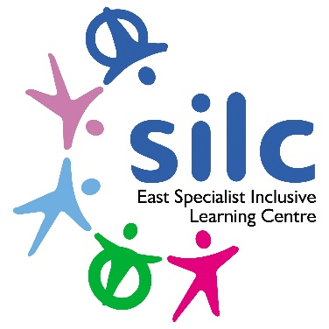
Outcome
Whilst there is no formal drawing of any proposals for a crossing in this location, it is a scheme that has been placed on our future programme of works.

The Safer Roads Programme budget runs in 5-year cycles and the current programme (2022-26) is now in its final year. We are currently in the process of putting together the 2027-32 Safer Roads Programme which will need to be agreed with our colleagues in the West Yorkshire Combined Authority by Summer 2026. Following this we will be looking to apportion all our prospective schemes into this 5-year programme to determine when they can be delivered.

