
Takeover of the Leeds SEND and AP Improvement Board
November 2025

Opening
On Tuesday 25th November 2025, 33 students from Future Steps Broomfield, Powerhouse West SILC, Pivot Academy, Green Meadows Academy, The Bridge East SILC, John Jamieson East SILC, Penny Field school and Enterprise and Employability Leeds City College took over the Leeds Area SEND and AP Partnership Board as part of national takeover challenge.

The aim of the takeover was to:
- Learn about each other.
- Learn about the issues that are important to young people with SEND.
- Agree how services will work with students to tackle the issues raised.



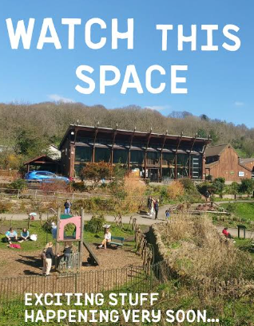
Obligation
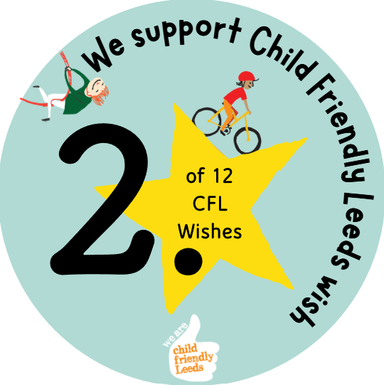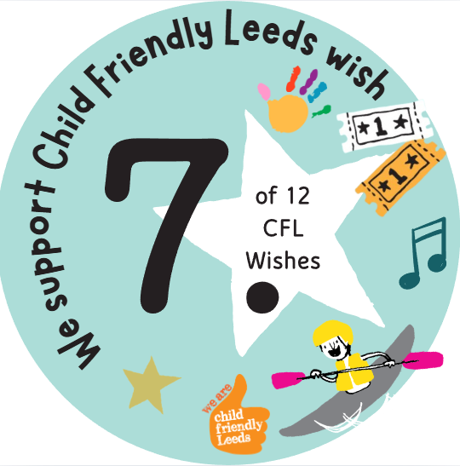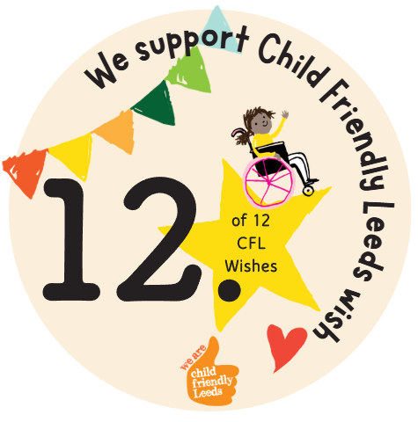

We support Child Friendly Leeds wish

Outcome
Officers from Leeds City Council consulting with students from the school when new play areas are being developed.

Students have been involved in providing feedback about Meanwood Valley and Horsforth Numerical Playground.

Opportunity
Students from Green Meadows shared with the board that playgrounds need to be more accessible and inclusive.

Actions agreed at the Takeover in November 2025:

- Students to provide feedback on inclusive play spaces designs within the draft 'Design Principles for Play' document.

- Green spaces service to work with the school on other playground improvements across the city as a regular consultee.

