


Leeds SEND Youth Council involvement and achievements
1st September 2025 to 31st August 2026

The Leeds SEND Youth Council is group of young people aged 11 to 25 years old with special educational needs and disabilities (SEND) who live in Leeds or attend school in Leeds.

The Leeds SEND Youth Council take part in a range of youth voice activities that enable them to share their experiences and feedback about SEND services in Leeds.

Feedback from consultations with children and young people with SEND can be found here: https://www.leedslocaloffer.org.uk/have-your-say/children-and-young-people/consultation-feedback

Contact VIC@leeds.gov.uk for more information about the Leeds SEND Youth Council.

Regional representation
Representing the voices of young people in Leeds on a regional level.
Two members of the SEND Youth Council joined the Yorkshire and Humber regional SEND Youth Alliance group to represent the voices of young people in Leeds.

The regional group are:
- Developing a video about EHCP’s for young people
- Representing groups on the SEND Change programme

Campaigns

Mental Health Campaign
Members submitted questions for the Children’s Society – Time for Young people project about accessibility and inclusion of their drop in service.

In November members worked with Mindmate and shared their views on accessibility and how young people look for support and discussed barriers to accessing services. They also explored ideas for a SEND‑specific services page, and the group may help produce this content in 2026.

Sensory spaces
In March the group decided to run a campaign on increasing and improving Sensory spaces in Leeds. The members have written an email inviting shopping centres to collaborate with them on create a sensory space where young people can visit to help them regulate. This has been shared with Child Friendly Leeds Ambassadors such as Trinity Leeds, White Rose Centre and the Light. A research trip is planned for October half term to visit Broadway sensory room in Bradford with Councillor Manaka and staff from Child Friendly Leeds.

Hidden Disabilities
Ahead of Disability Pride month members recorded voice overs for an online campaign to Raise Awareness of Hidden Disabilities.

Disability Pride
Supported by the Leeds Youth Voice team, the SEND Youth Council planned and delivered This Is Us: Proud to Belong – A SEND Celebration at Leeds Kirkgate Market as part of Disability Pride Month. More than 150 children, young people and families joined us to celebrate disability pride through performances and creative activities, creating a welcoming space where everyone could feel proud to belong.
“A fantastic event and display... a really empowering event.”
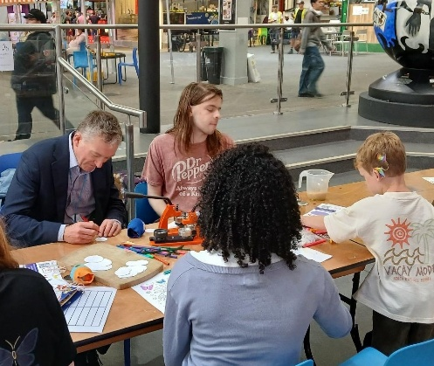
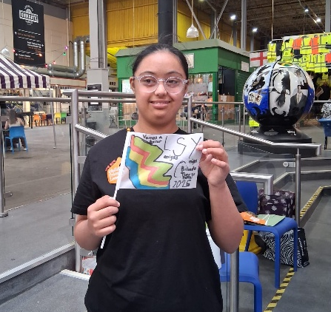
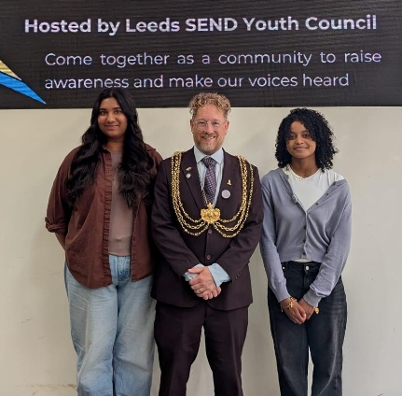
“I got to talk to the Mayor of Leeds which was cool”
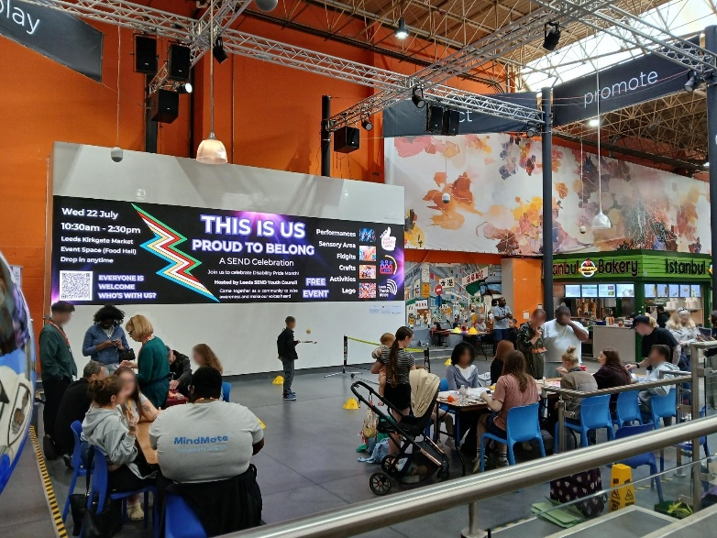
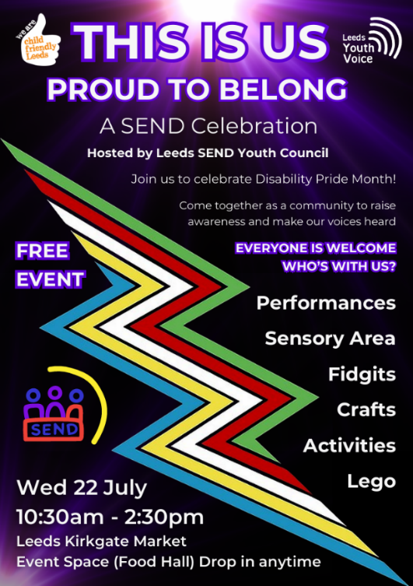

Recruitment and Commissioning panels
Members of the Leeds SEND Youth Council take part in young people recruitment and commissioning panels.
Recruitment Panel – Children and Families Chief Officers
In July, two members of the SEND Youth Council took part in interview panels for the Chief Officer of SEND and Learning Inclusion and Chief Officer Family Help and Social Work along with young people from the Children in Care Council and Leeds Youth Council. Following the interviews, Pete Thorpe Director of Children’s Services personally thanked the young people involved, recognising the value of their time, insight and contributions to the recruitment process.

Sessions
Each month members of the Leeds SEND Youth Council are invited to join sessions, the sessions are an opportunity for members to share their feedback and views with SEND services.
Filming Training videos
Members filmed videos to accompany some Leeds City Council and NHS staff SEND awareness training.

SEND Youth Council Promotional material review
Members reviewed current promotional materials and have begun to create a welcome video for new members.

Leeds Local Plan
In September 2025 members took part in the Leeds Local Plan consultation about land use and housing in Leeds. The group gave great feedback and ideas which has been shared with the Local Plan officers in Leeds City Council.

Youth Voice Groups Takeover, January 2026
Members took part in a Youth Voice Takeover event at Leeds Civic Hall. They spoke to leaders from the Children and Young People’s Partnership Board about their raising awareness of hidden disabilities campaign. They shared artwork and ideas to support the campaign. From this, Teams backgrounds have been created so staff can help promote the campaign it in their meetings.

Preparing for Adulthood
The Leeds SEND Youth Council took part in a Preparing for Adulthood workshop as part of a project with SENDIASS. Members shared their feelings about growing up, what they already know, and what they want to learn about adulthood. Their feedback will help create accessible resources to support young people with SEND to understand their rights and prepare for adult life.

Accessercise App Consultation
In January 2026 the group worked with staff from Active Leeds to review a new app that will be available for members of Leeds City Council gyms called Accessercise. The App has different exercises for disabled people to use with videos explaining how to adapt certain gym exercises. Members gave their feedback about the app including about accessibility features, reviewing gyms and creating an area for Nutrition information. This has been feedback to the App developers.

Youth Voice Matters Conference
In February 2026 3 representatives from the Leeds SEND Youth Council attended the Youth Voice Matters conference. The event was at NEC in Birmingham alongside over 100 other young people with SEND. They explored Youth Citizenship, connected with other young people took part in workshops and even heard a speech from the Minister of School Standard, Georgia Gould.

Light Night Leeds- Accessibility
Members took part in an online session about Leeds Light Night with Leeds City Council’s Event Team. They shared ideas about what would make the event easier and nicer to enjoy, like more seating, quieter spaces, ear defenders, and better transport. The events team listened to our feedback and will use it to help plan this year’s Light Night.

Rowland Play Patch
In March, members visited Rowland Play Patch again to see how the new sensory space is coming along. Since our last visit, there is now a sandpit, bright colours, mirrors, tunnels, places to sit, and plants you can touch and smell. We shared new ideas too, like wind chimes, ribbons at the entrance, a hide-out space, and ways to make the car park feel more welcoming.
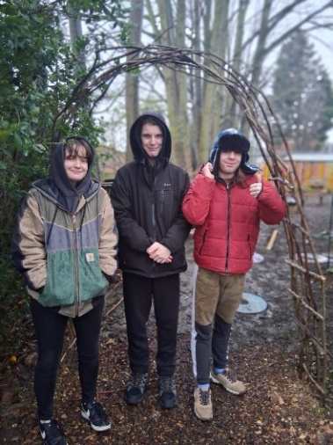
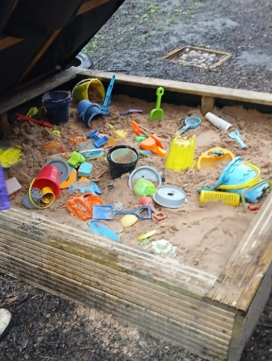
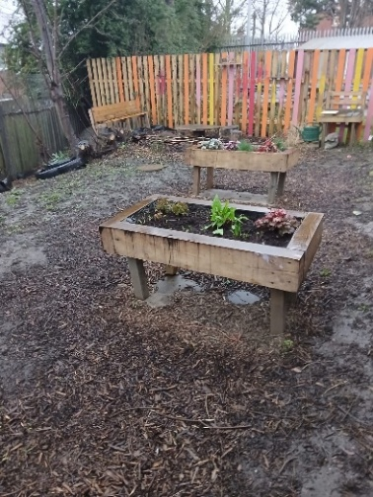

White Paper
The Leeds SEND Youth Council took part in a national consultation on the Government’s Schools White Paper, sharing their views alongside other young people across Leeds. They explored proposed changes to SEND support in education, shared what works well and what needs to improve, and their feedback will help inform future education policy.

Councillor Question and Answer
In June, The SEND Youth Council attended an event to meet with local councillors to ask questions and discuss local issues that are important to young people. The event took place at The Carriageworks, hosted by Leeds Youth Voice. Other youth councils attended including Leeds Youth Council., Care Leavers council and the Young Leaders. The councillors attending were Councillor Hayden, Councillor Manaka, Councillor Scopes, Councillor Carlill and Councillor Flynn.

Time for Young People
Also in June, the Leeds SEND Youth Council went on a trip to visit Time for Young People, a mental health service for young people in Leeds. The members went on a tour and reviewed the accessibility of the venue, including suggesting adding a red emergency cord to the toilet. They also gave their feedback about the space and service, answered questions, shared their experience and gave suggestion. Click here to view a video about the trip.

Leeds Local Offer information for young people
Members reviewed Local Offer information designed for young people. The information included two booklets; ‘Things to do’ and ‘Information for young people’ that included information about SEND services in Leeds. Members gave their feedback about the colours used, format and the content.

Leeds SEND & Alternative Provision Strategic Plan.
The SEND Youth Council helped by sharing feedback on the short guide and easy read version of the Leeds SEND & Alternative Provision Strategic Plan.
After an inspection of SEND services in Leeds in June 2026, local organisations worked together to update their plan.
The plan sets out the changes they will make to improve support, services and opportunities for children and young people with SEND and their families.

Consultation surveys
Consultation surveys are shared with the Leeds SEND Youth Council to enable them to give their views and feedback via online surveys.
Harewood Trust Play Signage Survey- consulting children and families about accessible signage at Harewood House, creating new, easy-to-understand signs for the Playscape at Harewood.

Youth Activity Fund – consulting young people about youth activities in their communities.

National Youth Agency- The Department for Culture Media and Sport (DCMS) are supporting Leeds City Council to undertake a review of youth provision and young people’s needs in Leeds.

West Yorkshire Transport Future- The Mayor’s Local Transport Plan is a chance to share views on how transport across West Yorkshire should look in the future.

Meanwood Valley Urban Farm inclusive playground- Meanwood Vally Urban Farm would like children, young people, parents and carers to look over the two potential plans for their new playground.

Ofsted and CQC inspection of services for children and young people in Leeds with SEND- online survey for children and young people to share their views about services in Leeds. Feedback will help Ofsted and the CQC understand what is working well and what could be better for children and young people with SEND.

