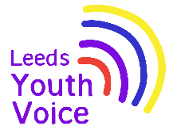
Voice, Influence and Change (SEND)
April to September 2026
We are asking services to share ‘You Said, We Did’ case studies explaining the work they have carried out with children, young people, parents and carers (e.g. consultations, surveys, focus groups etc.) in order to feed this back to:

- Children, young people, parents and carers
- Children and families’ strategic boards
- Councillors
- The wider Voice, Influence and Change network

All case studies can be found at https://tinyurl.com/LeedsVIcasestudies

Voice and influence of children and young people
- SEND and AP Improvement Board Takeover – issues important to young people (wish 6, 7 & 12)

- Harewood House play space signage (wish 2 & 12)

- The Mayors West Yorkshire Local Transport Plan (wish 6 & 12)

- Meanwood Valley Urban Farm playground (wish 2 & 12)

- Support in schools, Council for Disabled Children (wish 10 & 12)

- Accessercise App, Active Leeds (wish 9 & 12)

- SEND Coordinators, Family Hubs (wish 1, 3, 4, 7, 8, 9, 10, 11 & 12)

- Schools White Paper, Department for Education (wish 3, 10 & 12)

- Give it a Go event for schools (wish 1, 3, 7, 9 & 12)

- LCHT Youth Board review speech and language support plan templates (wish 1, 3, 4, 9, 10 & 12)

Voice and influence of parents and carers
- Home to School Transport, Voice Influence & Transparency Group (wish 6)

- Waiting lists for diagnosis and support, Voice Influence & Transparency Group (wish 12)

- Extended School Non-Attendance (ESNA), Voice Influence & Transparency Group (wish 10 & 12)

- Information for families where English is a second Language, Voice Influence & Transparency Group (wish 12)

- Schools White Paper, Department for Education (wish 3, 10 & 12)

- Supporting pupils with medical conditions at school – Government Response (wish 10 & 12)

SEND and AP Improvement Board Takeover 2025
Progress update May 2026
Opening
On Tuesday 25th November 2025, 33 students from Future Steps Broomfield, Powerhouse West SILC, Pivot Academy, Green Meadows Academy, The Bridge East SILC, John Jamieson East SILC, Penny Field school and Enterprise and Employability Leeds City College took over the Leeds SEND and AP Improvement Board as part of national takeover challenge.
The aim of the takeover was to:
- Learn about the issues that are important to young people with SEND.
- Agree how services will work with students to tackle the issues raised.

Opportunity and outcome

School | Issue | May 2026 update
Power House, West SILC | Accessible and affordable activities including access to PAs, variety of activities, promotion and information for families. | The PA service are contacting school to arrange consultation session with students to explore what they would like from a PA.
John Jamies, East SILC | Safety – pedestrian crossing outside school | Whilst there is no formal drawing of any proposals for a crossing in this location, it is a scheme that has been placed on our future programme of works.  The Safer Roads Programme budget runs in 5-year cycles and the current programme (2022-26) is now in its final year. They are currently in the process of putting together the 2027-32 Safer Roads Programme which will need to be agreed with the West Yorkshire Combined Authority by Summer 2026.

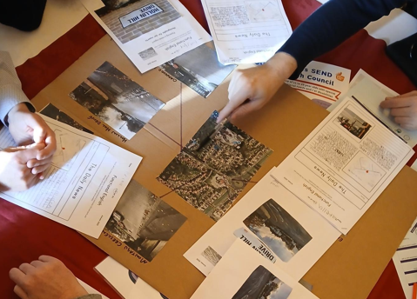
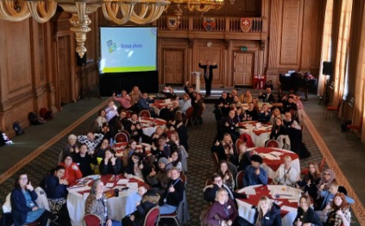
Obligation
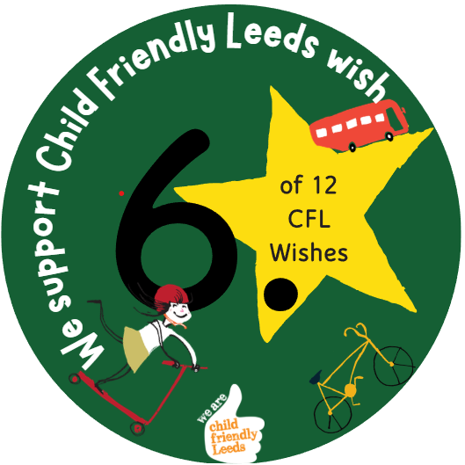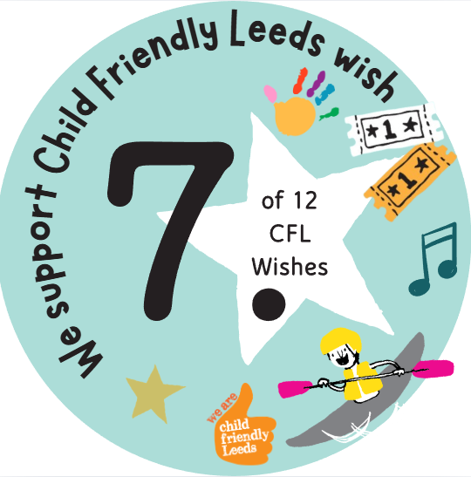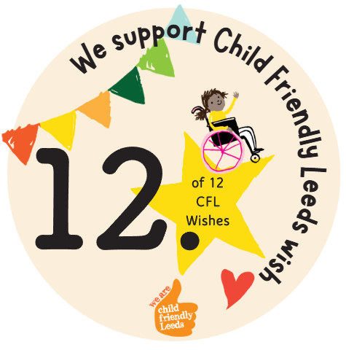

We support Child Friendly Leeds wish

Harewood House
April 2026

Opportunity
The insights gained from the survey and focus groups were subsequently utilised to inform design of the initial draft of the map.
Outcome
Harewood House are now in the process of sharing the outline design for the map with Leeds City Council, and we will then proceed with next steps to get the sign installed. As this map is part of our overall planning conditions for the playground, it is taking slightly longer than it usually would to have the sign installed, as it is part of a bigger process.
Obligation
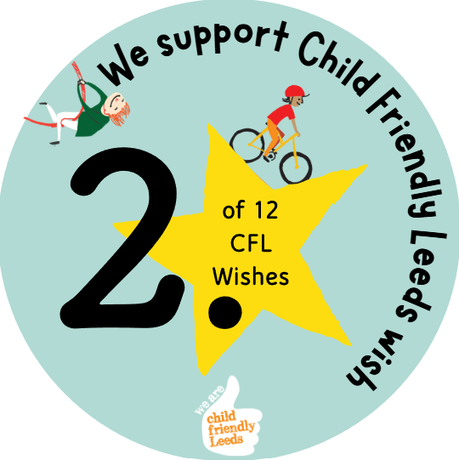

We support Child Friendly Leeds wish

Opening
Harewood House wanted young people, parents and carers to share their views on how play signage can be improved at Harewood House.

In September 2025; 7 participants complete the online survey to share their views about play signage.

In addition to the survey, Harewood House ran a number of focus groups with local community groups, which looked at further layout questions.

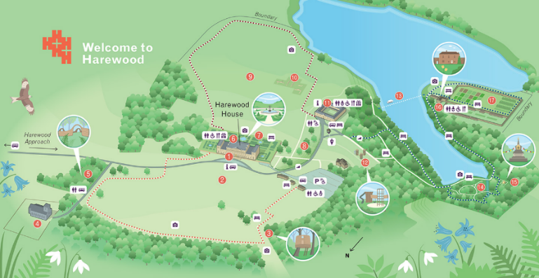
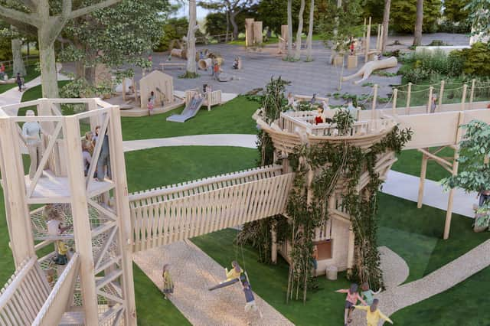


The Mayors West Yorkshire Local Transport Plan
October 2025
Opportunity
Lots of people agreed with the transport plan and thought it was a good idea overall. Most people liked the plans to improve how buses, trains and other travel work, and there were no big disagreements.

People said they want transport to be easy to use, safe and not too expensive. They also want better services at night and weekends, clearer information, and transport that works for everyone, including people with disabilities.

Some people were a bit worried about how the plan will work in real life, like making sure different areas are treated fairly and that big projects are affordable. They also want transport to be safe, better for the environment, and good for all communities.

Outcome
The Local Transport Plan will now guide future transport investment and projects across West Yorkshire, including major programmes like bus franchising and mass transit.

Delivery will happen through a series of Implementation Plans, with the first (covering 2026–2032) being developed in 2026 to set out specific schemes and priorities.

There will also be further engagement and consultation as individual projects are developed, alongside continued work to improve accessibility, safety, and service quality across the transport network.

Obligation

We support Child Friendly Leeds wish

Opening
Between 29 July and 21 October 2025, the West Yorkshire Combined Authority consulted on the Local Transport Plan, receiving over 1,300 written responses and engaging a similar number of people through workshops and focus groups.

The Voice, Influence & Change Team shared the online consultation with the Leeds SEND Youth Council.

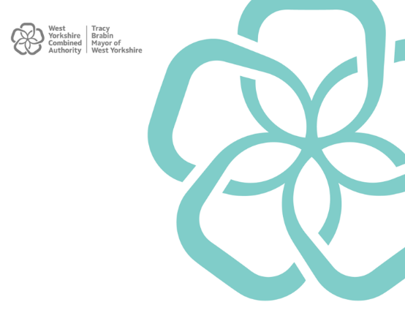

Meanwood Valley Urban Farm Playground
October 2025
Opportunity
There is strong support for creating a larger, more inclusive playground, with separate areas for toddlers and older children and a wider range of equipment, as the current space is seen as too small and limited.

Accessibility, safety and inclusion are key priorities, including fully accessible paths and equipment, better supervision (clear sightlines and fencing), and more sensory and SEND-friendly play features.

At the same time, people want to retain the natural, calm feel of the playground, avoiding large or overly manufactured equipment, and improving supporting features like seating, shade, and toilets.

Outcome
The findings from the consultation were well received and have provided a clear direction for the project. The feedback gathered has helped inform plans for the new playground and will support decision-making as the project progresses.

The next stage is awaiting confirmation from the main donor, who will be funding the majority of the playground costs. Subject to approval, contractors will be appointed and work is expected to begin on site in September.

This demonstrates how children and young people’s views have directly contributed to shaping a community space that reflects their needs and priorities.

Obligation

We support Child Friendly Leeds wish

Opening
Meanwood Valley Urban Farm consulted on the potential plans for their new playground.

51 people responded to the online consultation, including 10 members of the SEND Youth Council.

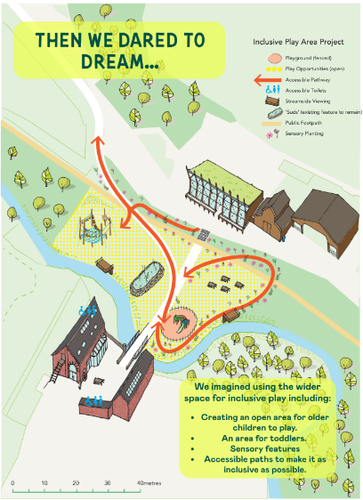
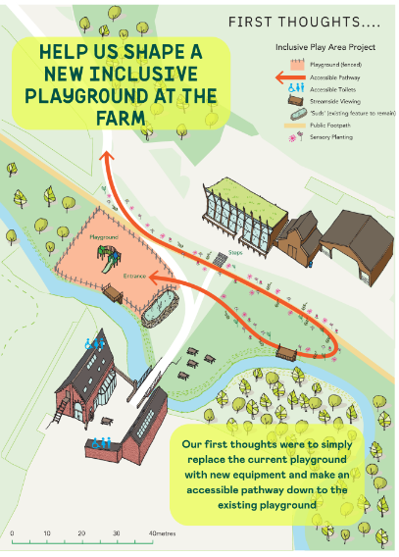

Support in Schools - Council for Disabled Children
January 2026
Opportunity
Young people highlighted that many education staff did not have sufficient SEND knowledge or training to understand their needs and provide appropriate support. Eighty-five per cent of respondents did not believe staff had enough SEND training to help them learn effectively and communicate in ways that worked for them.

Young people reported that a lack of staff understanding had negatively affected:
- Understanding schoolwork (74.3%)
- Mental health (73%)
- Worry and anxiety (73%)
- Completing work (68.9%)
- Making friends (48.7%)
- Attendance (47.3%)
- Feeling lonely (44.6%)

Young people also felt that receiving support earlier could have improved:
- Mental health (78.4%)
- Learning and attention (71.6%)
- Grades and achievements (71.6%)
- Communication (64.9%)
- Friendships and relationships (54.1%)
- Attendance (44.6%)

Outcome
The survey was designed to gather robust evidence about young people's experiences and to strengthen the case for improved SEND awareness and training within education settings. The consultation findings have been used to demonstrate the impact that insufficient SEND knowledge has on attendance, learning, mental health and inclusion.
Obligation
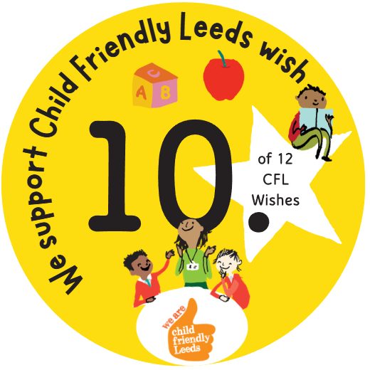

We support Child Friendly Leeds wish

Opening
A consultation was carried out with 75 young people with SEND aged 8–25 years to explore their experiences of support and understanding from staff in educational settings.

This work followed findings from the Collective Get Together 2025, where 297 young people identified improved SEND training for teachers and SENDCOs as one of their top three priorities for change within the SEND system.

The findings were further explored during a Power Hour session on 15 September 2025 involving 9 young people from 6 regions across England.

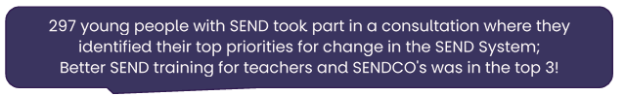

Active Leeds – Accessercise App
July 2026
Opportunity
The app and its features were shared with the young people.

Feedback was shared about the app, and discussion about the app and the council’s attitudes towards exercise and other technology.

The feedback was passed onto the app developers and then shared with the creator of the app after the session.

Outcome
Based on feedback the following developments are being made:

Nutrition area
Accessercise are currently actively developing this area and using the council’s feedback when doing so.
“Rate accessibility” – more questions / separate star ratings (accessibility, staff, equipment)
Accessercise are looking at incorporating separate star ratings and asked ‘If you can share what questions they felt were missing, we can prioritise the most valuable ones.’

Night mode
Logged this formally as a product improvement and it is the product timeline.

Add Active Leeds low sensory sessions
Active Leeds and Accessercise are actively looking into how to make this work.

Safe warm-ups and cool-downs
Accessercise are filming these so they should hopefully be available soon.
Obligation
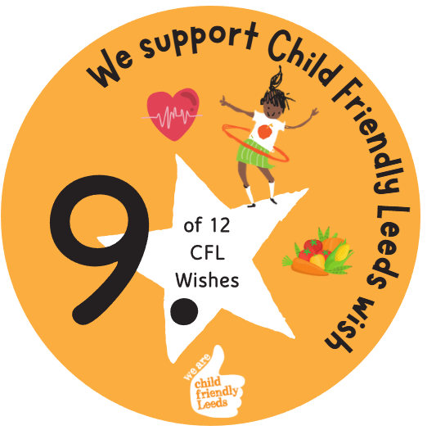

We support Child Friendly Leeds wish

Opening
Active Leeds presented the Accessercise App to the SEND Youth Council on the 23rd January 2026. There were 3 members of the Youth Council.

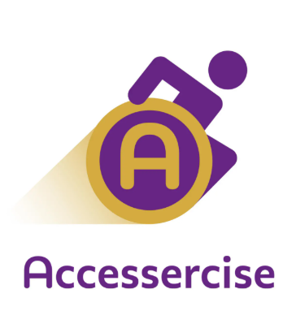

SEND Coordinators, Family Hubs
February 2026

Opportunity
We knew there would be lots of young people at the event, so we wanted to talk to as many of them as we could!

We asked young people what they thought about some of our ideas for the Family Hubs.

They used green, orange and red stickers to show us how they felt. Most people used green stickers, which means they liked our ideas! For example, they liked ideas like “helping parents and carers get the right support” and “helping schools and colleges.”

Young people also shared their own ideas, such as having more groups where they can meet other young people.

Outcome
A lot of our work is with parents and carers, but we know we need to do more to help children and young people understand what we do.

We would love to set up groups for young people. One of our jobs is also to find out what groups, clubs, and support are already available in your community, and to make sure families know about them.

After the Summit, we will work with young people and families to create information about Family Hubs that is especially for young people.

Obligation
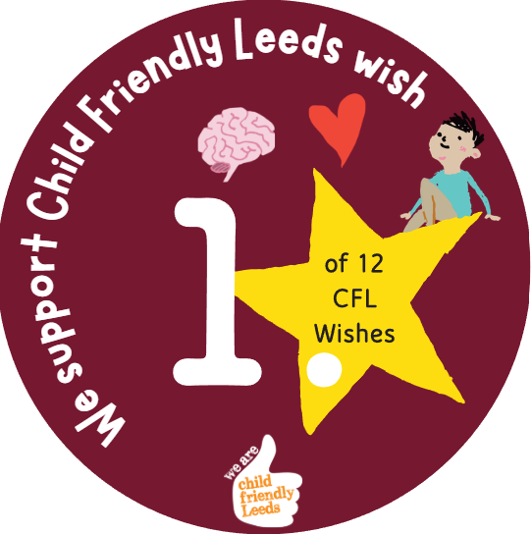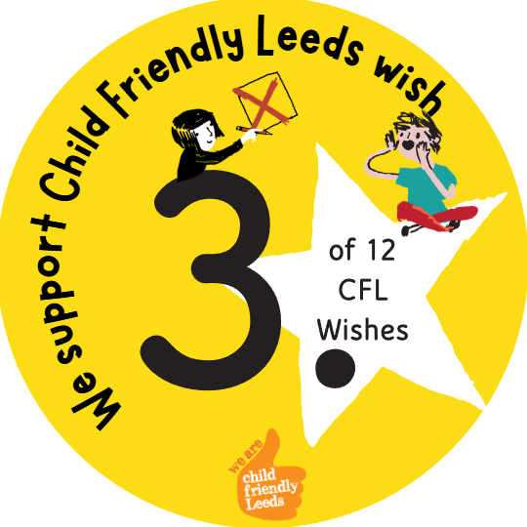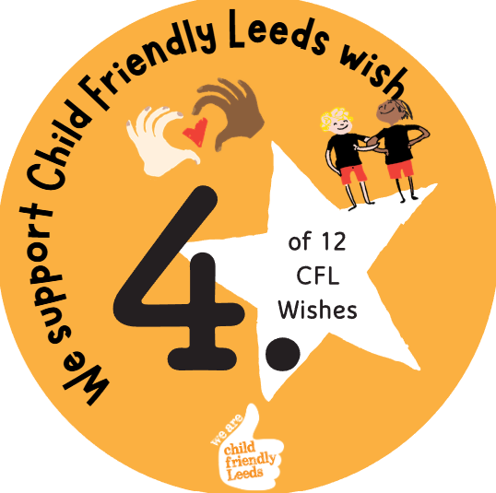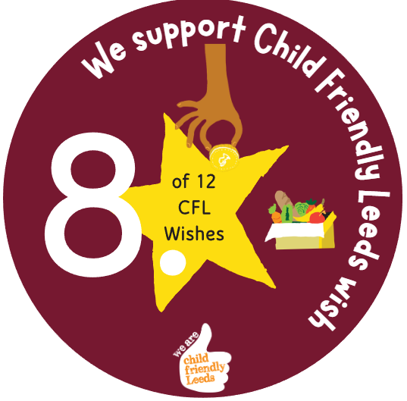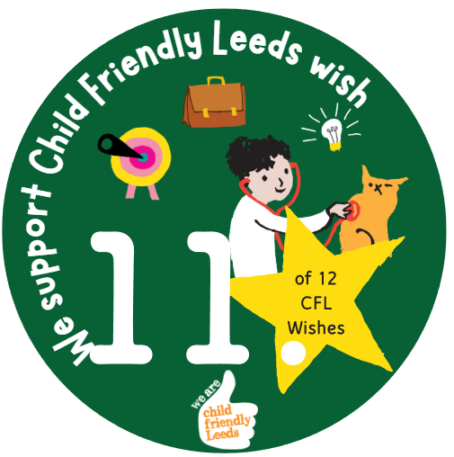

We support Child Friendly Leeds wish

Opening
The Family Hubs were invited to come to the SEND Summit and have a stall during the lunch break. We had presented last year to tell everyone about our SEND Coordinators, and it was great to be part of the Summit again.



Schools White Paper (young people)
May 2026
Opportunity
What young people thought of the proposed changes?

👍 Liked  - Teachers getting SEND training  - More help in school  - Inclusion bases (extra support in school)  - More children getting help earlier | 🤔 Not sure about  - How will it all work?  - What will change in school?  - What are “layers of support”?  - How will new plans work? | 😟 Worries  - Not getting enough help  - Losing EHCP support  - Losing specialist schools  - Things not being fair  - Being treated the same as others with different needs

Young people said:
- Change is needed
- But it must be clear, fair and safe
- And young people must be heard

Outcome
A detailed report has been shared nationally with the Government and will be considered as part of the consultation process for the Schools White Paper.

Obligation

We support Child Friendly Leeds wish

Opening
The Voice, Influence and Change Team asked young people what they think about new ideas for schools.

The Government wants to:
- Change how schools support children
- Help children with SEND get better support

These are just ideas, and the voice of young people will share what
happens next.

55 young people from 5 settings took part in the consultation.
- Leeds SEND Youth Council.
- The Bridge, East SILC.
- Ralph Thoresby School.
- Future Steps, Broomfield South SILC.
- Coop Academy.

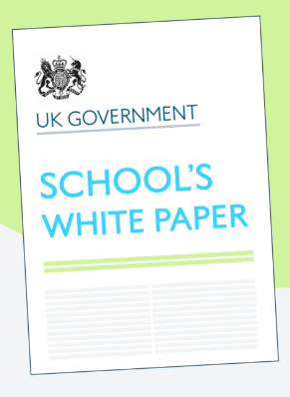



Give it a Go Event
April 2026
Opportunity
Now in its third year, Give it a Go Sports Day continues to bring together local providers, schools and partners to deliver an inclusive, welcoming experience. This year’s event included support from organisations such as Leeds United, Yorkshire Cricket Foundation, PE Partner, Breeze, Active Leeds and hosted in partnership with Leeds Trinity University.

Young people took part in a wide range of activities, including:
- Accessible bikes with Active Leeds
- Breeze games and inflatables
- Cricket with Yorkshire Cricket Foundation
- Football with Leeds United Foundation
- Gymnastics with Leeds Trinity
- Table tennis, Badminton & Basketball with PE Partner
- Sensory activities & Introduction to Mini First Aid.

Teachers, students and providers praised the event for creating a space where young people could explore new activities in a relaxed and supportive environment.

Outcome
Give it a Go will be an annual event run in partnership by Child Friendly Leeds, Voice and Influence and Leeds Trinity University.

During the event:
- 19 youth activity fund surveys were completed.
- 8 young people expressed an interest in joining the SEND Youth Council.
- 35 young people took information about the Leeds Local Offer.
- 40 young people took part in the Raising Awareness of Disabilities campaign.

Obligation

We support Child Friendly Leeds wish

Opening
Students with special educational needs and disabilities (SEND) across Leeds have continuously shared with us how they would like the opportunity to ‘try out’ different sports, groups and activities available to them in Leeds.

In July 2023; the first Give it a Go event was hosted and offered the opportunity for students to try out different sports and activities in a safe environment. 69 students attended the event.

Child Friendly Leeds and Leeds Trinity ran the event again in May 2025, with 100 students attending the event. Due to its success the event ran for a third year in April 2025, with 198 students attending.

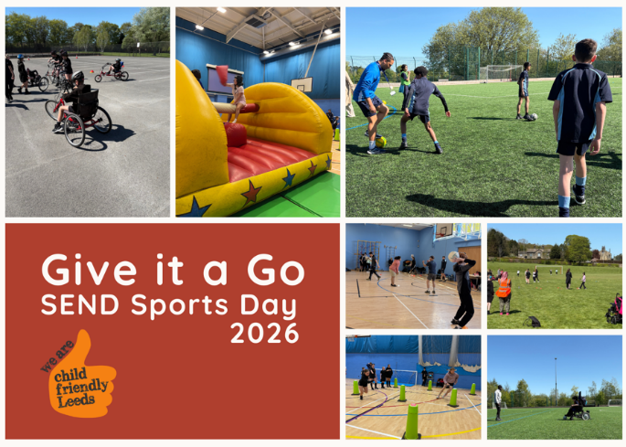

Children’s Speech and Language Therapy Service (CSLT) & Leeds Community Healthcare NHS Trust (LCH)

June 2026

Opportunity
Inviting the Youth Board to review CSLT report and support plan templates offers an opportunity to improve the clarity, accessibility and relevance of information provided to schools and parents/carers. Their feedback can help ensure language is easy to understand, reduce unnecessary jargon and make recommendations more user-friendly. Involving young people strengthens co-production, supports person-centred practice and ensures resources reflect the needs and experiences of service users. This can increase engagement with advice, promote self-advocacy, improve inclusivity and provide valuable quality assurance. It also demonstrates the service's commitment to participation, continuous improvement and working collaboratively with children and young people.

Outcome
The Youth Board provided valuable feedback that helped improve the clarity, accessibility and user-friendliness of CSLT report and support plan templates. They were happy that we use of understandable language and minimal jargon. The review strengthened co-production, increased confidence that documents meet the needs of service users. Overall, the process enhanced the quality and effectiveness of the information shared by the service, helping users better understand and act on the advice provided.

Obligation

We support Child Friendly Leeds wish

Opening
The Children’s Speech and Language Therapy Service have been updating the templates which we use for our reports and support plans. We write these after we have assessed a child or young person. It provides information for parents/carers, settings and the GP involved in a CYP care.



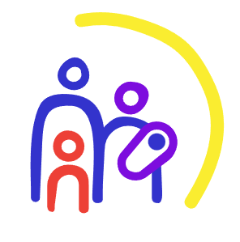

Voice, Influence & Transparency Working Group
April to September 2026
Opportunity
The Leeds Parent Carer Forum and Voice, Influence and Change Team (LCC) work in partnership to raise the issues and challenges faced by parents and carers of children with SEND in Leeds across education, health and care.

All issues and challenges raised are shared with the Voice and Influence Transparency Working Group and subsequently with the Leeds SEND and AP Improvement Board.
Outcome
The Leeds Local Offer Team worked in partnership with the Leeds Parent Carer Forum, Passenger Transport and Children’s Transport to host an online Home to School Transport information session for families (June 2026).

The session is available to view on the Leeds Local Offer website.

Obligation

We support Child Friendly Leeds wish

Opening
The Leeds Parent Carer Forum and Parent Carer Support Groups have shared feedback from families about Home to School Transport.

- Communication and coordination issues.
- Lack of flexibility and consistency.
- Need for a clearer process.

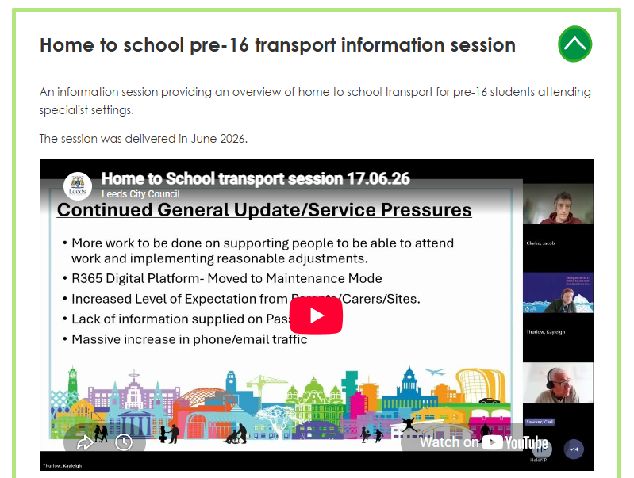


Voice, Influence & Transparency Working Group
April to September 2026
Opportunity
The Leeds Parent Carer Forum and Voice, Influence and Change Team (LCC) work in partnership to raise the issues and challenges faced by parents and carers of children with SEND in Leeds across education, health and care.

All issues and challenges raised are shared with the Voice and Influence Transparency Working Group and subsequently with the Leeds SEND and AP Improvement Board.
Outcome
The Leeds Parent Carer Forum have worked with health colleagues to bring together neurodiversity information and resources across Leeds and West Yorkshire.

The information is available on the Leeds Local Offer website.

Obligation

We support Child Friendly Leeds wish

Opening
The Leeds Parent Carer Forum and Parent Carer Support Groups have shared feedback from families about waiting lists for diagnosis and support.

- The waiting lists continue to be extremely long, and families are not getting the support they need.

- The delay in diagnosis can affect self-esteem and prevent children from learning.

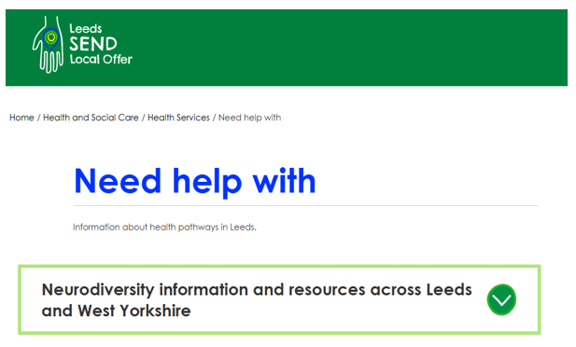

Voice, Influence & Transparency Working Group
April to September 2026
Opportunity
The Leeds Parent Carer Forum and Voice, Influence and Change Team (LCC) work in partnership to raise the issues and challenges faced by parents and carers of children with SEND in Leeds across education, health and care.

All issues and challenges raised are shared with the Voice and Influence Transparency Working Group and subsequently with the Leeds SEND and AP Improvement Board.
Outcome
Information about the Learning Access Service and contact details have been updated on the Leeds Local Offer website.

The Leeds PCF hosted a coffee morning with the Learning Access Team so parent carers can speak with them directly about their services.

The Leeds PCF are coproducing parts of the Inclusive Mainstream Practice (IMP) guidance for Parents and carers.

On Monday 23rd February 2026, the Leeds PCF hosted an event in partnership with the Voice, Influence & Change Team where parent carers could hear about the IMP and share their feedback and thoughts and ask questions.

Obligation

We support Child Friendly Leeds wish

Opening
The Leeds Parent Carer Forum and Parent Carer Support Groups have shared feedback from families about extended school non-attendance (ESNA).

- School attendance challenges.
- Impact on families.
- Need for improved school support.
- Rising demand and inconsistent practice.

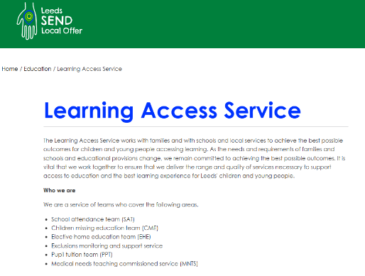

Voice, Influence & Transparency Working Group
April to September 2026

Opportunity
The Leeds Parent Carer Forum and Voice, Influence and Change Team (LCC) work in partnership to raise the issues and challenges faced by parents and carers of children with SEND in Leeds across education, health and care.

All issues and challenges raised are shared with the Voice and Influence Transparency Working Group and subsequently with the Leeds SEND and AP Improvement Board.
Outcome
SENDIASS, Leeds Local Offer and the Leeds Parent Carer Forum regularly meet to review how information can be developed so all families can access and understand SEND services.

Developments include:

- The Leeds Local Offer website enables users to change the language of the website.
- Introduction to the Leeds Parent Carer Forum video available in Urdu, Slovak, Tigrinya, Romanian, Farsi and Polish.
- Introduction to the Leeds Local Offer video available in British Sign Language, Farsi and Polish.

The services continue to work together to develop information in alternative languages.

Obligation

We support Child Friendly Leeds wish

Opening
The Leeds Parent Carer Forum and Parent Carer Support Groups have shared feedback from families about information for families where English is a second language.

- Families where English is a second language struggle to access SEND services and information.
- Families cannot always read written information and require it in a different format.

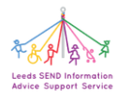



Schools White Paper (parents and carers)
May 2026
Opportunity
Parents and carers broadly support the aims of the SEND reforms (earlier help, better inclusion), but feel the proposals are too vague and lack clear delivery plans, with concerns about insufficient funding, workforce capacity and loss of specialist expertise.

There is little confidence that mainstream schools can meet more complex needs without major investment, with worries about underfunding, staff pressures, inflexible systems and unclear access to specialist support. Concerns also centre on new support plans, particularly around eligibility, accountability and whether legal rights may be weakened.

Overall, families are calling for stronger accountability, clearer safeguards and better long-term outcomes, especially improved post-16 provision, life skills and mental health support, warning that without these, reforms are unlikely to deliver real change.

Outcome
A detailed report has been shared nationally with the Government and will be considered as part of the consultation process for the Schools White Paper.

Obligation

We support Child Friendly Leeds wish

Opening
The Leeds Parent Carer Forum hosted two online sessions for Leeds parents and carers specifically to discuss the Schools White Paper and SEND Reform Consultation. This is alongside a Padlet (online message board) to provide our families with the consultation documents and to gather the views of our parents and carers.

They also drew on our collective experience as a parent carer forum and all the engagement we have had with local parents and carers over the course of the last few years via:
• School SEND coffee mornings.
• PCF hosted workshops.
• PCF hosted coffee mornings and afternoon teas.
• Local Offer drop-in events.

The Leeds Parent Carer Forum have 664 registered members.

Supporting pupils with medical conditions at school – Government Response
July 2026
Opportunity
Across all questions:
- A clear majority of respondents strongly agreed or agreed with the proposals, demonstrating consistent support for the direction of travel. Only two questions recorded “strongly agree” levels below 60% (both approximately 58%). When combining “agree” and “strongly agree” responses, no question fell below 84% agreement, with most questions achieving between 88% and 95% agreement.
- Support was consistent across respondent groups, including parents, education staff, senior leaders, and healthcare professionals, indicating broad cross-sector alignment.
- Where disagreement was expressed, this focused primarily on implementation and delivery considerations, rather than opposition to the underlying principles.
Outcome
The government has carefully considered all responses.

While there is a clear mandate to strengthen statutory guidance, respondents
consistently highlighted challenges relating to capacity, funding, workforce
capability, training delivery, and clarity of responsibility between education and health systems.

They will revise the draft statutory guidance to reflect the points raised. However, they recognise that further work is needed to clarify the respective roles and responsibilities of education settings and of healthcare professionals. They will take this forward with the Department of Health and Social Care before publishing updated statutory guidance for education settings on supporting children and young people with medical conditions in due course.

There was clearer consensus over the importance of supporting children and young people with allergies. Since the consultation began, the Children’s Wellbeing and Schools Act 2026 has introduced new statutory duties on schools to put allergy safety policies in place. They will therefore publish statutory guidance on allergy safety, reflecting feedback received through the consultation.
Obligation

We support Child Friendly Leeds wish

Opening
The government consulted on proposals to strengthen statutory guidance on supporting children and young people with medical conditions and allergies in education settings. The consultation sought views on a range of key issues, including clarity of responsibility, the role and use of Individual Healthcare Plans (IHPs), staff training, allergy safety, the reporting of incidents and near misses, and the scope of statutory duties across different types of education provision.

1,882 responses submitted via the online consultation platform and a further 27 responses received by email.

