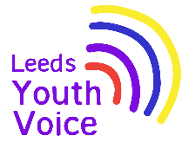
Supporting pupils with medical conditions at school – Government Response
July 2026
Opportunity
Across all questions:
- A clear majority of respondents strongly agreed or agreed with the proposals, demonstrating consistent support for the direction of travel. Only two questions recorded “strongly agree” levels below 60% (both approximately 58%). When combining “agree” and “strongly agree” responses, no question fell below 84% agreement, with most questions achieving between 88% and 95% agreement.
- Support was consistent across respondent groups, including parents, education staff, senior leaders, and healthcare professionals, indicating broad cross-sector alignment.
- Where disagreement was expressed, this focused primarily on implementation and delivery considerations, rather than opposition to the underlying principles.
Outcome
The government has carefully considered all responses.

While there is a clear mandate to strengthen statutory guidance, respondents
consistently highlighted challenges relating to capacity, funding, workforce
capability, training delivery, and clarity of responsibility between education and health systems.

They will revise the draft statutory guidance to reflect the points raised. However, they recognise that further work is needed to clarify the respective roles and responsibilities of education settings and of healthcare professionals. They will take this forward with the Department of Health and Social Care before publishing updated statutory guidance for education settings on supporting children and young people with medical conditions in due course.

There was clearer consensus over the importance of supporting children and young people with allergies. Since the consultation began, the Children’s Wellbeing and Schools Act 2026 has introduced new statutory duties on schools to put allergy safety policies in place. They will therefore publish statutory guidance on allergy safety, reflecting feedback received through the consultation.
Obligation
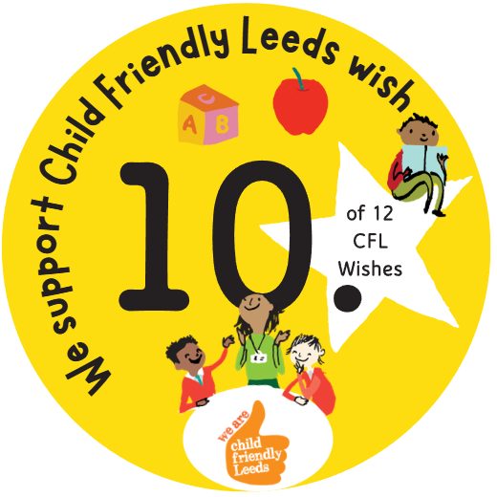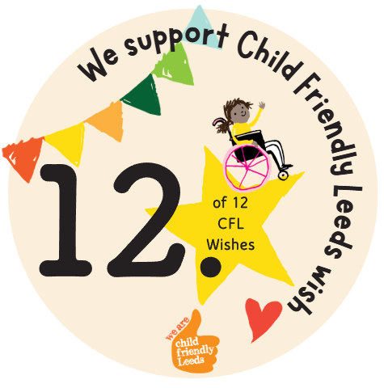

We support Child Friendly Leeds wish

Opening
The government consulted on proposals to strengthen statutory guidance on supporting children and young people with medical conditions and allergies in education settings. The consultation sought views on a range of key issues, including clarity of responsibility, the role and use of Individual Healthcare Plans (IHPs), staff training, allergy safety, the reporting of incidents and near misses, and the scope of statutory duties across different types of education provision.

1,882 responses submitted via the online consultation platform and a further 27 responses received by email.

