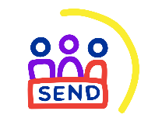
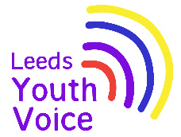

Voice and influence of young people with SEND within schools
2025/26

The Voice, Influence and Change Team work in partnership with schools across Leeds to provide opportunities for students with special educational needs and/or disabilities to have a voice and influence on SEND services.

By taking part in the various voice and influence projects students have grown in confidence and gained valuable skills such as team working, organisational skills, employability skills, increased awareness of voting and democracy as well as making friends from across the city.

This report shares voice and influence highlights from the 2025/26 academic year.

You can view this report, previous reports and the voice and influence offer to schools on the Leeds Local Offer website.

Content:
- Takeover of the Leeds Area SEND and AP Partnership Board
- SEND Summit
- Compass House
- Democracy Session
- Consultations
- Give it a Go
- Preparation for Adulthood resources
- 2026/27 voice and influence projects

For more information about any of the projects, or to register your interest in being involved contact VIC@leeds.gov.uk

Takeover of the Leeds Area SEND and AP Partnership Board
Every November students with SEND from across Leeds schools’ takeover the Leeds Area SEND and Alternative Provision Partnership Board. The Takeover is an opportunity for students to share with board members the issues that are most important to them.

On Tuesday 25 November 2025, 33 students from Future Steps Broomfield, Powerhouse West SILC, Pivot Academy, Green Meadows Academy, The Bridge East SILC, John Jamieson East SILC, Penny Field school and Enterprise and Employability Leeds City College took over the Leeds SEND and AP Improvement Board as part of national takeover challenge.
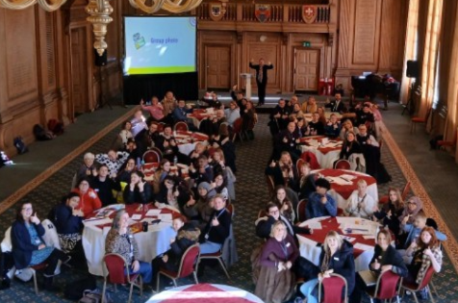
The aim of the takeover was to:
- Learn about each other.
- Learn about the issues that are important to young people with SEND.
- Agree how services will work with students to tackle the issues raised.

The full takeover report can be downloaded here.

SEND Summit
The SEND Summit provides an opportunity for secondary aged students with SEND to come together to give their views and opinions on service delivery and development as well as finding out about services that are available to them.

The event is a great opportunity for students to meet others, hear about services, visit Leeds Civic Hall and make a difference.
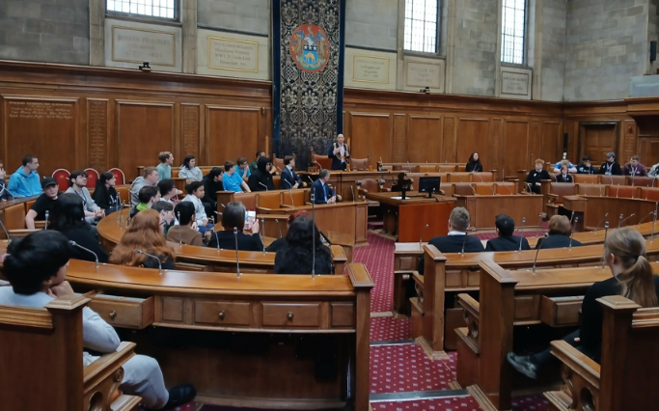

On Wednesday 11 February 2026, 53 students from learning settings across Leeds came together at Leeds Civic Hall to take part in consultations and activities that enabled them to have a voice and influence.

- West SILC: Powerhouse
- West SILC: Milestones
- West SILC: Co-op Academy Priesthorpe Partnership
- East SILC: John Jamieson
- East SILC: The Bridge
- Broomfield South SILC
- Broomfield South SILC: Future Steps
- Green Meadows Academy
- Lighthouse School
- Leeds Jewish Free School
- Springwell Academy East
- Future Horizons

Students took part in the Youth Activity Fund consultation, Neurodiversity Information Hub consultation, learnt about democracy and met with the Lord Mayor and Interim Director of Children and Families.

The full event report can be downloaded here.

Compass House
In 2017; 102 students from across the SILCs took part in the Mark Your Mark ballot (largest youth consultation in the UK). From the ten issues, the students collectively voted that a Curriculum to Prepare us for Life as the top issue for them. Students took over the Leeds Area SEND and AP Partnership Board in November 2017 and spoke to the board about what a curriculum for life means to them and how they would like valuable work experience.

In response, the Compass House work experience project was set up in 2018. With support from Leeds City Council, staff from specialist schools across Leeds supported students to come together to plan and open their very own pop-up shop for one week during the month of December in Kirkgate Market. Students meet monthly from September to December to make all the decisions about the shop (known as Compass House) including making all the products to sell.

Due to the success of the project in 2018, this has now become an annual event.


In December 2025; 112 students from East SILC, West SILC, Broomfield South SILC, Green Meadows Academy, The Lighthouse School, Coop Academy Brierley and Future Horizons had the opportunity to work at the Compass House pop up shop, with hundreds of students contributing to making products to sell.

The full project report can be downloaded here.

Democracy sessions
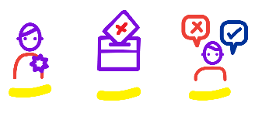
The Voice, Influence and Change Team offer 60-minute democracy sessions which can be delivered within the school setting at any point during the school year.

The sessions focus on local democracy and introducing young people to voting.

This academic year 47 students from Leeds West Academy, John Jamieson East SILC and Broomfield South SILC have taken part in democracy sessions.

Consultations
Schools White Paper

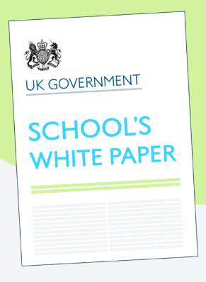
The Voice, Influence and Change Team asked young people what they think about new ideas for schools.

The Government wants to:

Change how schools support children

Help children with SEND get better support

These are just ideas, and the voice of young people will share what happens next.

55 young people from 5 settings took part in the consultation.

Leeds SEND Youth Council.

The Bridge, East SILC.

Ralph Thoresby School.

Future Steps, Broomfield South SILC.

Coop Academy.

A detailed report has been shared nationally with the Government and will be considered as part of the consultation process for the Schools White Paper.

click here to download the summary report for young people.

click here to download a visual case study of the consultation.

Give it a Go event
Students with special educational needs and disabilities (SEND) across Leeds have continuously shared with us how they would like the opportunity to ‘try out’ different sports, groups and activities available to them in Leeds.

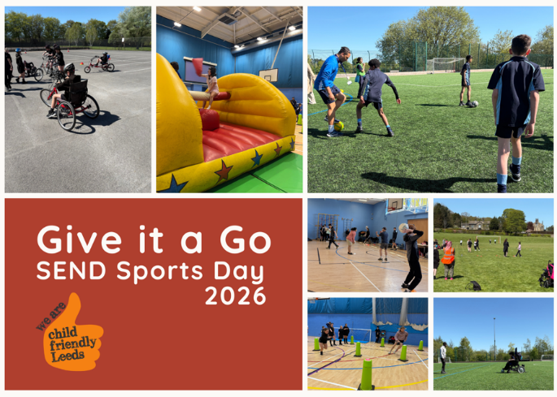
In July 2023; the first Give it a Go event was hosted and offered the opportunity for students to try out different sports and activities in a safe environment. 69 students attended the event.

Child Friendly Leeds and Leeds Trinity ran the event again in May 2025, with 100 students attending the event. Due to its success the event ran for a third year in April 2025, with 198 students attending.

Now in its third year, Give it a Go Sports Day continues to bring together local providers, schools and partners to deliver an inclusive, welcoming experience.

Teachers, students and providers praised the event for creating a space where young people could explore new activities in a relaxed and supportive environment.

During the event:
- 19 youth activity fund surveys were completed.
- 8 young people expressed an interest in joining the SEND Youth Council.
- 35 young people took information about the Leeds Local Offer.
- 40 young people took part in the Raising Awareness of Disabilities campaign.

click here to download a visual case study about the event.

Preparation for Adulthood resources
The Voice, Influence and Change Team have worked in partnership with SENDIASS (SEND Information, Advice and Support Service) to consult with 56 learners (pre and post 16) to learn about what information they require to equip and enable them to achieve and thrive in a supported internship pathway.

Based on the feedback from learners the team are working with the Leeds City Council comms team to develop 10 e-publications that can be printed, and 10 YouTube shorts to sit alongside the publications.
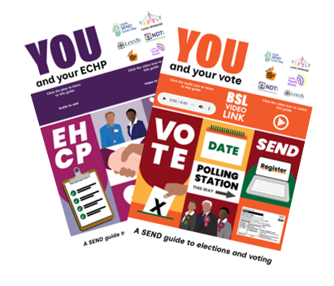
- Careers, Jobs and Volunteering
- Money and finance
- Voting and elections
- Accessing health care services
- Relationships and friendships
- Puberty and personal hygiene
- Transport
- Living independently
- SEND support and EHCPs

These are currently in development, and we will be launched at the beginning of the 2026/27 academic year.

2026/27 voice and influence projects

Takeover of the Leeds Area and AP Partnership Board
The takeover will take place in November 2026, with preparation sessions with students taking place in October. The takeover will be delivered as an event at which students and board members will work together on local issues raised by students in specialist settings in Leeds.

Compass House (specialist settings only)
Planning meetings will take place in September, October and November 2026 with the pop-up shop opening for one week in December 2026.

SEND Summit
The SEND Summit will take place on Tuesday 9th February 2027, 10am till 1.45pm at Leeds Civic Hall.

Give it a Go
The Give it a Go event will run again in 2027; schools will be sent a date once confirmed.

Democracy sessions
The Voice, Influence and Change Team offer 60-minute democracy sessions which can be delivered within the school setting at any point during the school year. The sessions focus on local democracy and introducing young people to voting. Sessions can be booked by emailing VIC@leeds.gov.uk

Consultations
Services across Leeds contact the Voice, Influence and Change Team when they are seeking the views of young people in their service review and developments. When these requests are made the team will contact schools and offer to run consultation sessions within the school setting to provide students with the opportunity to have their voices and views heard and listened to.

For more information about any of the projects, or to register your interest in being involved contact VIC@leeds.gov.uk

