
Voice, Influence and Change (SEND)
October 2025 – March 2026
We are asking services to share ‘You Said, We Did’ case studies explaining the work they have carried out with children, young people, parents and carers (e.g. consultations, surveys, focus groups etc.) in order to feed this back to:

- Children, young people, parents and carers
- Children and families’ strategic boards
- Councillors
- The wider Voice, Influence and Change network

Voice and influence of children and young people
- Health and Wellbeing Services – support for schools (wish 12)

- Neurodiversity Information Hub – support for young people (wish 1)

- Changes to the STARS team offer – SEND support in school (wish 10)

- SEND and AP Improvement Board Takeover – issues important to young people (wish 2, 3, 7 & 12

- Takeover of the Children and Young People’s Partnership Board – raising awareness of disabilities (wish 12)

Voice and influence of parents and carers
- Leeds Parent Carer Forum & Health Services - ARFID support (wish 12)

- Voice, Influence & Transparency Working Group – EOTIS (wish 10)

- Voice, Influence & Transparency Working Group – Preparation for Adulthood (wish 10)

- Voice, Influence & Transparency Working Group – Professionals’ knowledge of SEND services (wish 12)

- Voice, Influence & Transparency Working Group – Information about SEND services (wish 12)

- Voice, Influence & Transparency Working Group – financial support for families (wish 8)

- Voice, Influence & Transparency Working Group – Education transitions (wish 10)

- Inclusion Advisory Team Service – Inclusive Mainstream Practice (wish 10)

- Strategy and Resources, LCC – Leeds City Council Directories (wish 12)

- Leeds Local Offer – Evening SEND information sessions for families (wish 12)

- Briggate Action Plan – tackling travel issues raised (wish 6)

Health and Wellbeing Services
February 2026

Opportunity
We had prepared some multi choice questions, around SEMH, for pupils to answer.

These could be multiple responses or a single response.

Outcome
The information will be used to complement the rest of the My Health My School Survey results collected from across the SEND survey results across the city.

This will inform our current and future offer to SILC settings and schools e.g. training opportunities for staff, training for pupils and resources we share.
Obligation
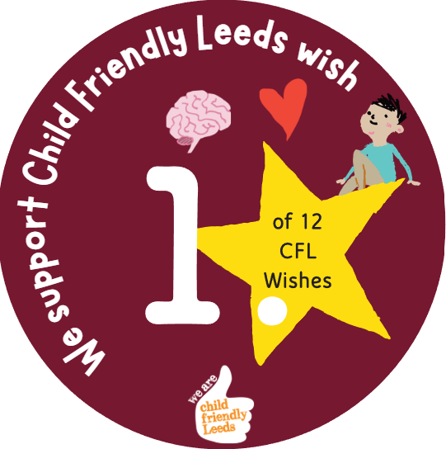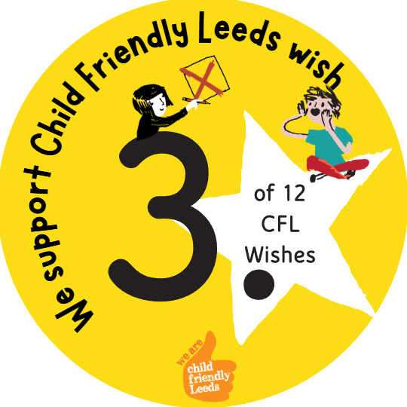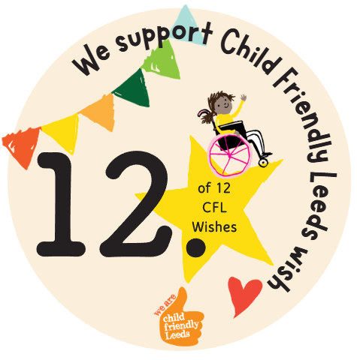

We support Child Friendly Leeds wish

Opening
Consultation stall with students at the SEND Summit on the 11th February 2206.

Consulted with 20 students around social, emotional wellbeing and mental health.

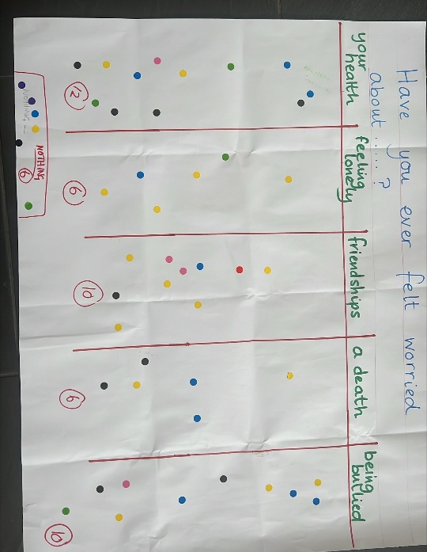
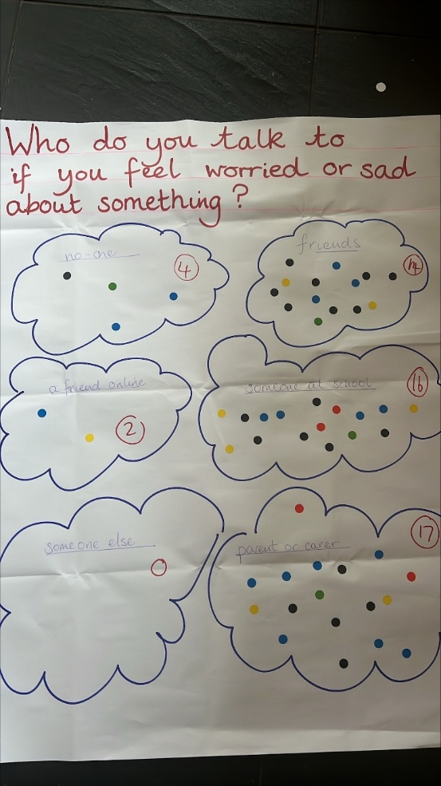

Neurodiversity Information Hub (NHS)
February 2026
Opportunity
A brief video demonstration of the information hub resource was shared with the group, followed by the young people answering the 4 below questions in groups.
- Have you seen the ND Info Hub website before? If so, did you find it helpful?
- What would you find helpful to have on a website about neurodivergence (e.g. autism, ADHD, dyslexia, learning disability)
- How would you like the information to be shared? (e.g. writing, pictures, videos, audio, diagrams)
- Where would you look for this information? (e.g. school, online, social media, books, AI).

You said:
It was good to see that many of the suggested information and formats already exist on the current resource.

Themes for developments: No-one had used the resource before, so better access and promotion is needed. Social media was a core source of information, so we need to utilise social media more. Many suggested more videos, interactive activities, diagrams, colour filter changes and more colourful, engaging designs. More ND voices are also needed. ‘How to handle it/deal with it’ was also a highlighted as a focus that we need to explore in more detail.
Outcome
The information has been collated and will be shared with the commissioners, website developers/ designers and the clinicians involved.

This will help guide the team on prioritising and funding future developments.

Developments will be organised into small changes that can be completed as a priority, followed by larger changes that will need more commissioner involvement.

We are very grateful for your voices and ideas and will do our best to make the changes you want!
Obligation
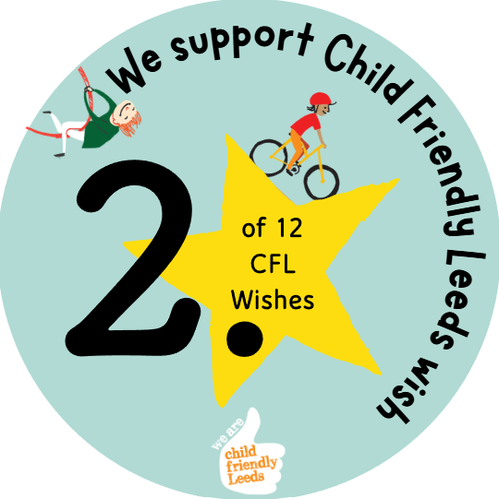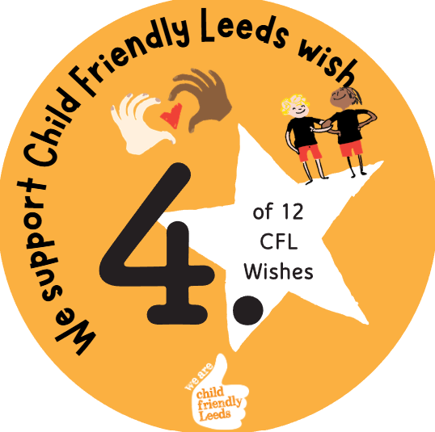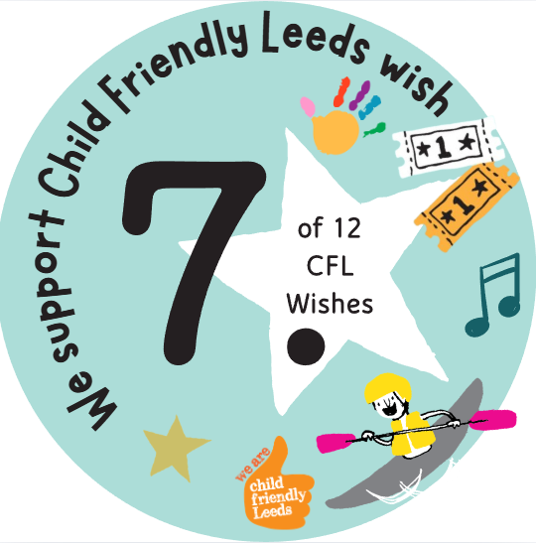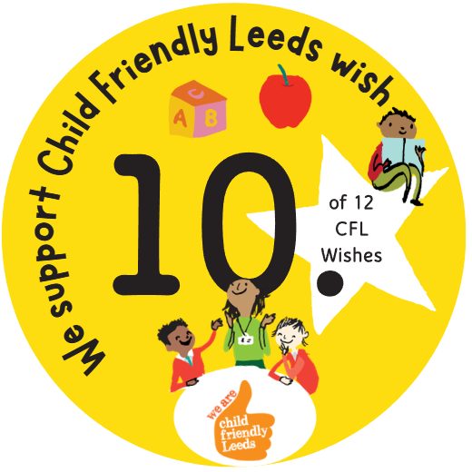

We support Child Friendly Leeds wish

Opening
The Neurodiversity Information Hub digital resource was taken to consultation at the SEND Summit on 11th February 2026 at Leeds Civic Hall.
The resource was shared with 52 young people from 11 specialist educational settings across the city to seek their views and feedback.

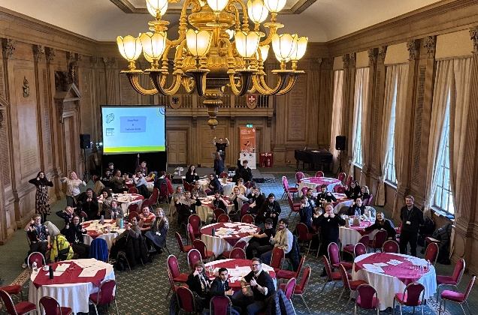
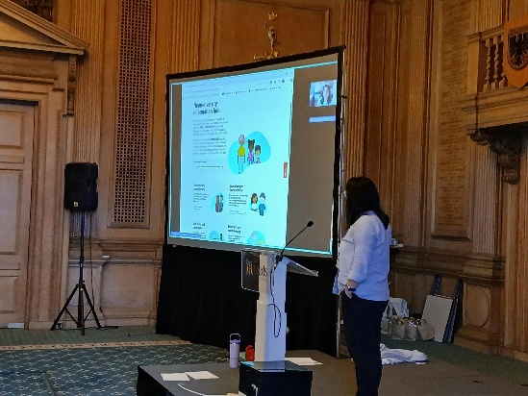

STARS Team
June 2025

Opportunity
The SEND Youth Council gave insightful feedback and we have listened.

They commented that the move to a needs-led model would make services more accessible and help children and parents understand and address their needs better.

They asked that the team’s name should clearly describe the team's function and the service it provides. We hope ‘Inclusion Advisory Team’ does that!

Young people also reflected that it is better to have one early year’s team and put all the funding into one team, and that is the plan going forward.
Outcome
The changes will come into effect 1st January 2026 and involve:
- SENIT & STARS teams will join together and will become known as Inclusion Advisory Team.
- The 4 distinct professional disciplines in SENIT & STARS will be maintained; early years, communication & interaction (including autism), learning & cognition, SEMH.
- STARS team will be known as the ‘Communication and Interaction (including autism) Team’. Overall though the team will be known as Inclusion Advisory Team.
- The Communication and Interaction (including autism) Team will no longer require autism diagnosis as a pre-requisite for settings accessing support for focused CYP work.
- Communication and Interaction (including autism) team will no longer provide early years offer. EY team will continue to provide this comprehensive support including a SEND home visiting offer (portage)
- There is much work to be done, and we will use this term to communicate with and work with schools and settings and wider partners so that this can be implemented effectively.

Opening
In June 2025; the STARS team consulted with 4 members of Leeds SEND Youth Council on the proposals to change the STARS team offer.

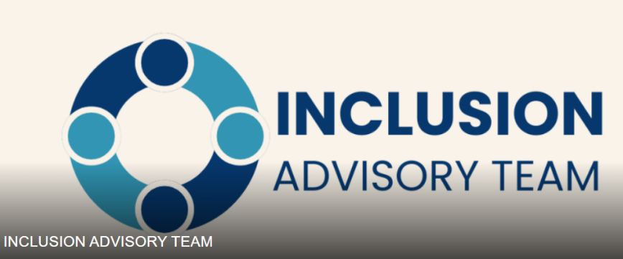
Obligation

We support Child Friendly Leeds wish

SEND and AP Improvement Board Takeover 2025
Progress update March 2026
Opening
On Tuesday 25th November 2025, 33 students from Future Steps Broomfield, Powerhouse West SILC, Pivot Academy, Green Meadows Academy, The Bridge East SILC, John Jamieson East SILC, Penny Field school and Enterprise and Employability Leeds City College took over the Leeds SEND and AP Improvement Board as part of national takeover challenge.
The aim of the takeover was to:
- Learn about the issues that are important to young people with SEND.
- Agree how services will work with students to tackle the issues raised.

Opportunity and outcome

School | Issue | March 2026 update
Green Meadows Academy | Accessible playgrounds / spaces | Officers are consulting with the school when new play areas are being developed. Students have been involved in providing feedback about Meanwood Valley and Horsforth Numerical Playground.
Pivot Academy | Raising awareness of sunflower lanyard | The Child Friendly Leeds Team have arranged to meet with students to share further sunflower merchandise, and work with them to create top tips for professionals when they see someone wearing the sunflower lanyard – as part of Raising Awareness of Disabilities campaign.
Pennyfield School | Outdoor toys and shelter | The school are setting up a fundraising team with staff and parents. Information about funding opportunities have also been shared with the school, with the offer of support to progress with these.
The Bridge, East SILC | Home to school transport | The summer route review planning for September 2026 has commenced. The service actively encourages drivers to dress up for Red Nose Day and Xmas.  All Drivers and PA’s receive support via their Appraisals around their role as a driver. Refresher training to all PA’s and Drivers is via a rolling programme.  The next staff briefing in person for all frontline staff is 30th April 2026.

Obligation

We support Child Friendly Leeds wish

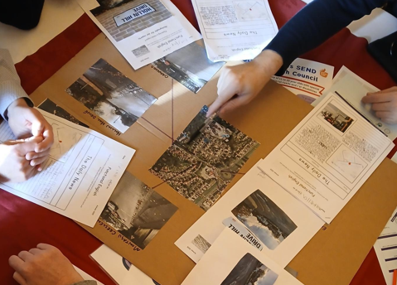
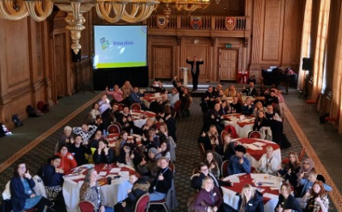

Takeover of the Children and Young People’s Partnership Board March 2026
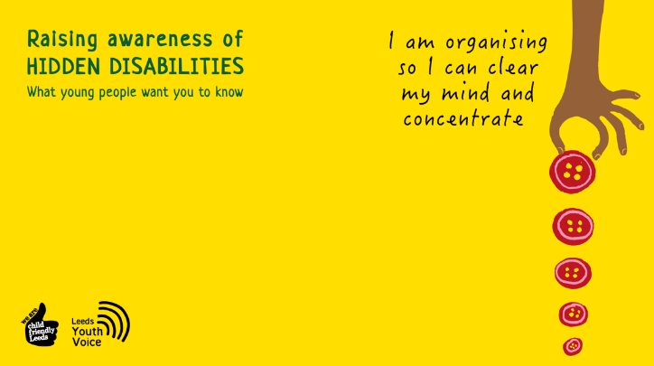

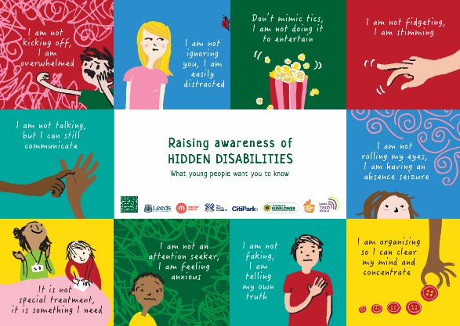
Opportunity
As part of our work to improve Wish 12, we’re focusing on making Leeds a more inclusive city.

Child Friendly Leeds and the Voice, Influence & Change Team have been collaborating with young people to explore how Leeds can become more welcoming and accessible for those with hidden disabilities.

Young people created artwork that has been developed into three posters that have been shared in venues across Leeds.

The SEND Youth Council spoke to members of the Children and Young People’s Partnership Board about how the campaign can be further supported. Board members suggested the artwork is turned into teams backgrounds that can be used by staff during online meetings.
Outcome
Teams backgrounds have been developed using the original artwork and is available to download here.

A communication has been sent out to Children & Families colleagues, and Health colleagues asking them to support the campaign by using the teams backgrounds during online meetings.
Obligation

We support Child Friendly Leeds wish

Opening
Members of the Leeds SEND Youth Council attended the Youth Voice Groups Takeover in January 2026. They spoke to members of the Children and Young People’s Partnership Board and Council Officers about the Raising Awareness of Disabilities Campaign.

Leeds Parent Carer Forum & Health Services
October 2025 to March 2026
Opportunity
Health issues in Leeds are ongoing. A member of the Voice, Influence and Transparency Working Group meets with the Leeds Parent Carer Forum and Health colleagues monthly to work on the health issues raised.

Outcome
Information about ARFID support has been added to the Leeds Local Offer website.

The Leeds Parent Carer forum have:
- Delivered an ARFID support workshop for parents and carers at the 2025 Leeds Local Offer Live event.

- Surveyed parents at the Leeds Local Offer Live event (March 2025) around ARFID support and also shared the survey electronically. The final report was shared with the ICB in February 2026.

- Facilitated an ARFID support coffee morning for families in September 2025.

Obligation

We support Child Friendly Leeds wish

Opening
Via the Leeds Parent Carer Forum, families have fedback that they feel services do not have the knowledge to support them with eating difficulties and there is no clear pathway for support / signposting to resources to support. This impacts on the child and their wider family and can limit social interactions and schooling.

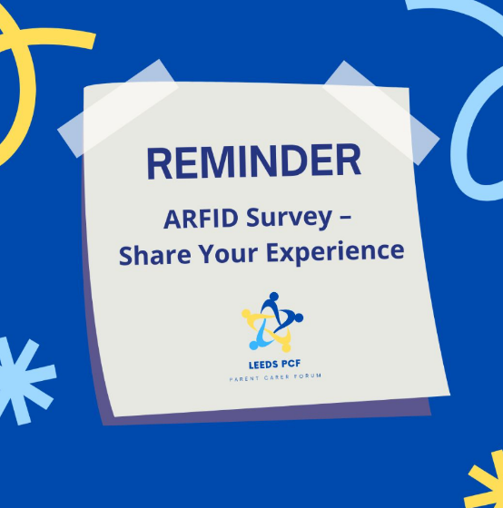
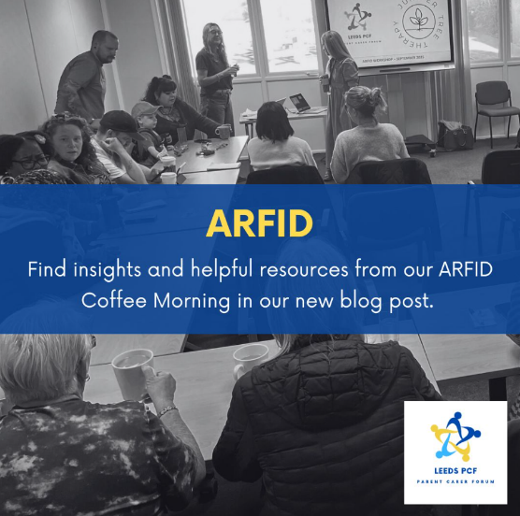

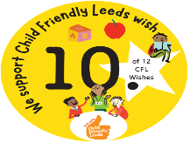
Voice, Influence & Transparency Working Group
October 2025 to March 2026
Opportunity
The Leeds Parent Carer Forum and Voice, Influence and Change Team (LCC) work in partnership to raise the issues and challenges faced by parents and carers of children with SEND in Leeds across education, health and care.

All issues and challenges raised are shared with the Voice and Influence Transparency Working Group and subsequently with the Leeds SEND and AP Improvement Board.
Outcome
EOTIS frequently asked questions have been developed and available on the Leeds Local Offer website (January 2026).

Information about the Learning Access Service has been added to the Leeds Local Offer website (January 2026).

The Educational Psychologist Team have consulted with the Leeds Parent Carer Forum to look at attendance barriers and what support can be developed for parents.

Resources have been developed by the Educational Psychologist Team for school staff (and professionals) to provide support with attendance.

Obligation

We support Child Friendly Leeds wish

Opening
The Leeds Parent Carer Forum and Parent Carer Support Groups have shared feedback from families about Education Other Than In School (EOTIS).
- Some parents and carers have fed back that they are increasingly having to give up work to support their child at home, as they cannot attend school due to school not being able to meet their needs. How do families challenge this?
- Families have shared that the local authority do not support EOTAS packages and naming them in EHCPs.
- Families wanting to undertake the EOTAS package have shared that there is no support available.

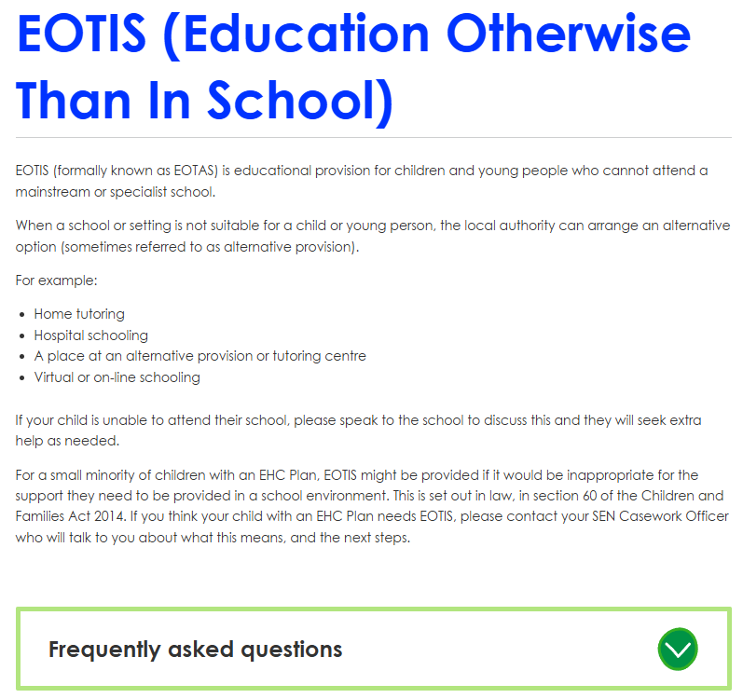


Voice, Influence & Transparency Working Group
October 2025 to March 2026
Opportunity
The Leeds Parent Carer Forum and Voice, Influence and Change Team (LCC) work in partnership to raise the issues and challenges faced by parents and carers of children with SEND in Leeds across education, health and care.

All issues and challenges raised are shared with the Voice and Influence Transparency Working Group and subsequently with the Leeds SEND and AP Improvement Board.

Outcome
Information about preparing for adulthood on the Leeds Local Offer website has been reviewed and updated.

The Leeds Local Offer Team have worked with specialist provisions to host localised PfA marketplace events for parents and carers.

Child Friendly Leeds are working with ambassadors and specialist post 16 provisions to enhance learn to work opportunities for students.

The Voice, Influence and Change Team and SENDIASS are working in partnership with young people to develop 10 themed PfA publications and YouTube shorts. These will be launched Mid 2026.

Preparing for Adulthood has been identified as a task and finish group that will report to the Leeds SEND and AP Improvement Board.
Obligation

We support Child Friendly Leeds wish

Opening
The Leeds Parent Carer Forum, Parent Carer Support Groups and Families have shared feedback about Preparation for Adulthood.
- There is no preparation for adulthood for children who are highly anxious.
- Lack of post 16 provision.
- Careers advice given in schools, but families not aware of the options available for their child.
- Families are provided with lots of information about preparation for adulthood, but the offer is not clear. For young people not in education there is a lack of information / pathways about their options.
- More support for young people with SEND as they transition to adulthood i.e. in college

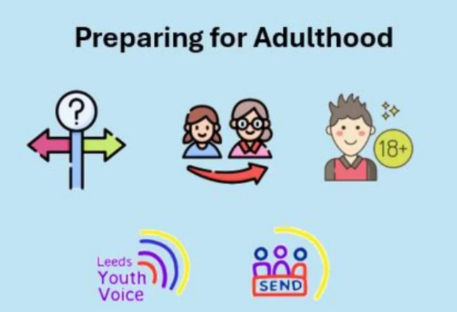

Voice, Influence & Transparency Working Group
October 2025 to March 2026

Opportunity
The Leeds Parent Carer Forum and Voice, Influence and Change Team (LCC) work in partnership to raise the issues and challenges faced by parents and carers of children with SEND in Leeds across education, health and care.
All issues and challenges raised are shared with the Voice and Influence Transparency Working Group and subsequently with the Leeds SEND and AP Improvement Board.
Outcome
- SEND training offer for school staff and SENCOs delivered by Learning Inclusion.
- Promotion of the Leeds Local Offer to education, health and social care professionals.
- The Children and Families Workforce Development Team have developed an online SEND basic awareness training package for all Children and Families staff. There are four key principals that all staff will be expected to complete. The training will include lived experience from parents, carers, children and young people.
- Inclusive Mainstream Practice resources, and information for schools and families was launched in November 2025 and is available on the Leeds Local Offer website.
- Consulted via an online survey for parents and carers to identify schools and area of need that requires further training (96 parent carer responded). A recommendations report will be shared early 2026.
Obligation

We support Child Friendly Leeds wish

Opening
The Leeds Parent Carer Forum and Parent Carer Support Groups have shared feedback from families about professionals’ knowledge of SEND services in Leeds:
- School staff require further SEND training to ensure they understand how to meet the needs of their children.
- School staff require more awareness of masking and need to reduce parent blame.
- Families would like professionals to show more empathy and understanding to families.
- Families would like to be involved in training and feel all training should include lived experience.
- Lack of neurodivergent expertise within leadership.
- Families feel professionals they come into contact with require more in-depth knowledge of SEND services available in Leeds.
- Families feel they receive different messages about service depending on who they speak to i.e. GPs, schools etc.
- Training for all services not just SEND i.e. housing.
- School staff have a lack of knowledge of SEND services in Leeds.




Voice, Influence & Transparency Working Group
October 2025 to March 2026
Opening
The Leeds Parent Carer Forum and Parent Carer Support Groups have shared feedback from families about information available to families about SEND services in Leeds:
- Advocacy for families attending meetings with schools and SEND services.
- Support for families to navigate SEND services and not just signpost.
- Sharing information about SEND school support with families.
- Information about youth groups and activities available.

Opportunity
The Leeds Parent Carer Forum and Voice, Influence and Change Team (LCC) work in partnership to raise the issues and challenges faced by parents and carers of children with SEND in Leeds across education, health and care.

All issues and challenges raised are shared with the Voice and Influence Transparency Working Group and subsequently with the Leeds SEND and AP Improvement Board.


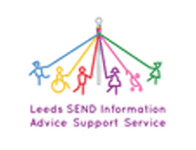
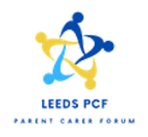
Obligation

We support Child Friendly Leeds wish

Outcome
- The Leeds Local Offer website has been furthered developed, and information about services reviewed.
- The Leeds Local Offer introduction to SEND services booklet is available on the Leeds Local Offer website, and in hard copy format. The booklet is reviewed and updated annually.
- Monthly SEND parent carer information drop ins including focussed workshops run in partnership by Leeds Local Offer, Leeds Parent Carer Forum, SENDIASS, Carers Leeds, CHAD and Speech and Language.
- Annual Leeds Local Offer Live marketplace event for families to find out about SEND services in Leeds.
- The Leeds Local Offer team host a facebook group and WhatsApp channel, and post daily to share information about SEND services with families.
- The Leeds Parent Carer Forum deliver workshops for families based on need.
- SENDIASS deliver their offer via their website, social media, YouTube, workshops etc. SENDIASS will have increased capacity in 2025/26.
- Seven new Family Hubs across the city, each hub has a SEND Coordinator.

Voice, Influence & Transparency Working Group
October 2025 to March 2026
Opening
Parent Carer Support Groups have shared feedback from families about financial support for families:

- Support around trusts and wills
- Support applying for PIP
- DLA claims taking 5 to 6 months to process
- Impact on families financially due to caring responsibilities

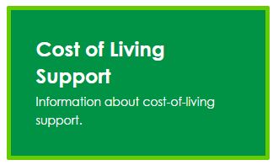
Obligation

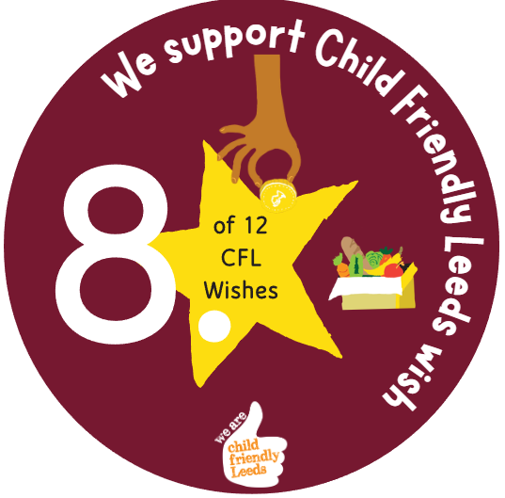

We support Child Friendly Leeds wish

Outcome
A section has been developed on the Leeds Local Offer website about financial advice and support and also cost of living support.

Opportunity
The Leeds Parent Carer Forum and Voice, Influence and Change Team (LCC) work in partnership to raise the issues and challenges faced by parents and carers of children with SEND in Leeds across education, health and care.

All issues and challenges raised are shared with the Voice and Influence Transparency Working Group and subsequently with the Leeds SEND and AP Improvement Board.

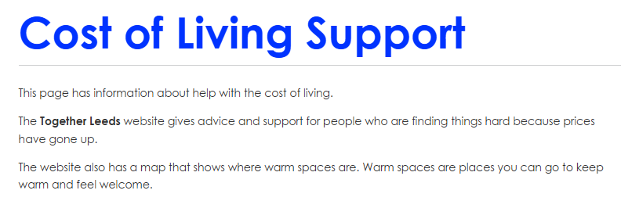

Voice, Influence & Transparency Working Group
October 2025 to March 2026
Opening
The Leeds Parent Carer Forum has shared feedback from families about transition support through education stages:

Lack of support, information and resources for all key stages of transition (primary to secondary, secondary to post 16, post 16 to next steps).

Opportunity
The Leeds Parent Carer Forum and Voice, Influence and Change Team (LCC) work in partnership to raise the issues and challenges faced by parents and carers of children with SEND in Leeds across education, health and care.

All issues and challenges raised are shared with the Voice and Influence Transparency Working Group and subsequently with the Leeds SEND and AP Improvement Board.

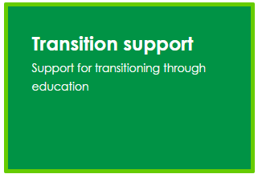
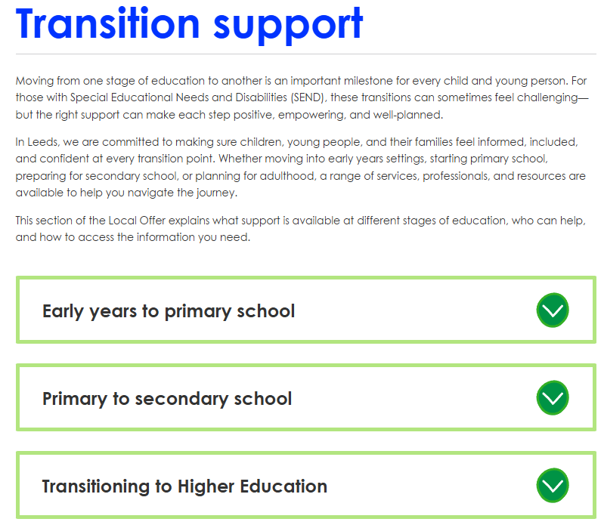
Obligation

We support Child Friendly Leeds wish

Outcome
Information about transition support through education has added to the Leeds Local Offer website.

Inclusion Advisory Team Service
February 2026
Opportunity
In Autumn 2025, we carried out a parent carer survey to help us better understand the experiences of children and young people with SEND who attend mainstream settings.

The survey was open for four weeks on the Local Offer and shared widely through the Parent Carer Forum. In total, 148 parents and carers responded.

Purpose of the IMP:
- Outline the provision and support that mainstream settings should be able to provide for all children and young people including those with Special Educational Needs and/or disabilities (SEND) attending an educational setting in Leeds.
- Help settings consider what extra support might be relevant for all children and young people who are not progressing at the rate they would expect.
- Help parents understand what settings will be doing.

Intended impact:
- Increased teacher confidence in supporting learners with SEND.
- Improved parental confidence in mainstream schools.
- Resources distributed more effectively.
Outcome
Following feedback from the parents and cares who attended the event, the team will be introducing the following to the parent carer section of the Inclusive Mainstream Practice:
- Videos to provide accessible overview.
- Provide information about pathways of support.
- Promote the IMP to families.
Obligation

We support Child Friendly Leeds wish

Opening
15 parents and carers attended the Parent Carer Support Group Network event on Monday 23rd February 2026 at Pudsey Civic Hall.

The event was an opportunity for the Inclusion Advisory Team to share the new Inclusive Mainstream Practice (IMP) with parents and carers and get their feedback.



Strategy and Resources
August 2025
Opportunity
What families told us
- Most families (over 9 in 10) use the internet to look for help or local services. Many start with Google or social media, rather than a specific website like the Leeds Local Offer or Leeds Directory.
- Some families said they had not heard of local directories and would find clearer signposting helpful.
- Families told us that information online needs to be easy to understand, trustworthy, and safe and available in plain English or different languages.
- A small number of families said they struggle with digital access or confidence, so they still prefer phone or face-to-face contact.
- Most people now use phones or tablets to search online, so it’s important that council websites are simple to use on mobile devices.

Outcome
The feedback received has helped shape our plans for the next phase of work, which has now been approved by the council.

We’re starting a project to bring together different information sources, like the Leeds Directory and other local listings into one shared and reliable “store” of services.

This means:
- Families will be able to find consistent, up-to-date information in one place, whether they visit the Leeds Local Offer or another council site.
- Services won’t need to update information in lots of different places, so details stay accurate and easier to find.
- The new system will eventually link to the Local Offer, helping families access SEND support, early help, and community services all in one journey.

Opening
Over the summer of 2025, we asked families and residents in Leeds to tell us how they find information about local services — including care, support groups, and community activities.

We wanted to understand what works well, what’s missing, and how we can make it easier for families to find trusted information online through the Leeds Local Offer and other council websites.



Obligation
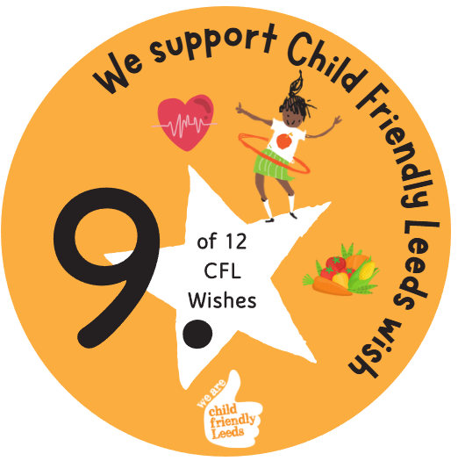

We support Child Friendly Leeds wish

Leeds Local Offer & Leeds Parent Carer Forum
March 2026
Opportunity
The Leeds Local Offer Team works closely with the Leeds Parent Carer Forum and SEND services to provide helpful information sessions for parents and carers.

These sessions are designed to:
share useful information about SEND services.
give families the chance to speak directly with SEND professionals.
offer practical workshops for parents and carers.

Sessions predominately take place during the day. However, after feedback from working parents, we explored hosting evening sessions with families.

Feedback from survey:
- Evening sessions to run between 6pm and 9pm.
- Sessions to be in person rather than online.
Outcome
The Leeds Local Offer and Leeds Parent Carer Forum are trailing an evening SEND information drop-in session for families.

The session will take place on Thursday 21st May 2026, 6.30pm till 8.30pm at the Vinery Centre.

The session will be promoted to families via support groups, services supporting families and, on the Leeds, Local Offer website.
Obligation

We support Child Friendly Leeds wish

Opening
The Leeds Parent Carer Forum and Leeds Local Offer Team consulted with parents and carers via an online survey during February / March 2026 to explore evening sessions with families.

12 parents / carers completed the survey and shared they would like evening sessions to be available.

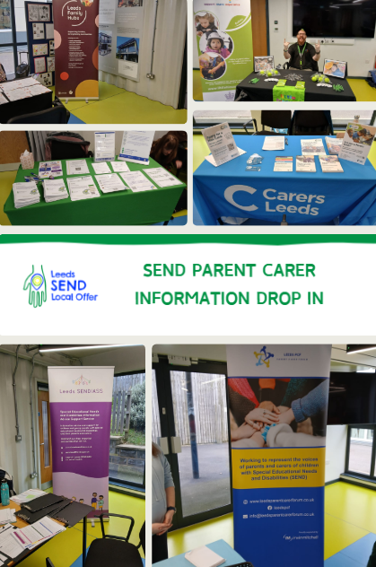

Briggate Action Plan
November 2025 to January 2026
Opportunity
As part of the consultation, which asked them if they would be in favour of:
- A requirement to walk with (rather than ride) bicycles and e-bikes within the city centre’s pedestrianised shopping area during pedestrianised hours. As well as Briggate, this area includes Lands Lane, Commercial Street, Albion Place and lower Albion Street. A total of 87 per cent of respondents were in favour.

- An extension to the hours during which this area is pedestrianised, from the current hours of 10.30am until 7pm to new hours of 10am until 8pm. Of those responding, 84 per cent were in favour.

- A prohibition of pedlars from defined areas. Pedlars are defined as non-static or mobile street traders and are not licensed by the council. On an average day Briggate will see around 15 pedlars, with many more gathering during key events such as Light Night Leeds. Consultation responses were 69 per cent in favour of restricting pedlars.

Outcome
After collating results and feedback from the consultation, Leeds City Council officers are now drawing up plans for the next phase of the scheme, which will include applying for new legislation enabling the restrictions to be put in place and enforced.

This will require the council to follow an extensive and detailed statutory process, but it is hoped the new measures will be implemented within the next 6-12 months.
Obligation
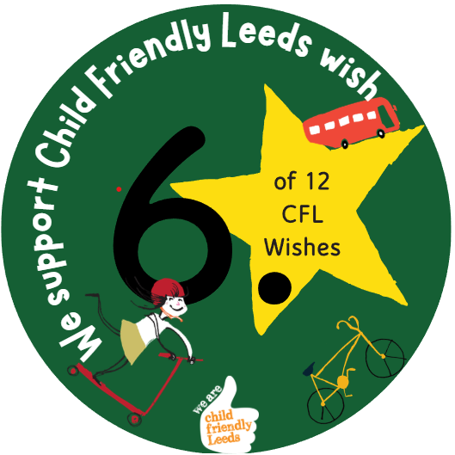

We support Child Friendly Leeds wish

Opening
Consultation on the Briggate Action Plan asked the public for their views on proposals aimed at tackling a number of concerns they had raised, including the estimated 1,100 bikes travelling up and down Briggate each day.

More than 2,100 people had their say as part of the consultation



