**Health Needs Assessment on the Health and Wellbeing of Young People in Leeds**

**Why did we do a Health Needs Assessment on Young People in Leeds?**

Leeds City Council want to make sure that every child has the ‘Best Start in Life’, and that children and young people are safe and healthy.  Between 2023 and 2024 the Public Health Children and Families team carried out a Children’s Health Needs Assessment and found there was a need to further understand the health needs of older children and young people. Many health and wellbeing issues start during around age 10-19, including mental health problems, tobacco and alcohol use, being overweight and lack of physical activity. Understanding the things that can negatively affect a young people’s health is important to provide the right help and support.

**What did we do?**

The health needs assessment considered the health needs of young people aged 11-19 years old who live in Leeds. It was recognised that a lot of research and consultation work had already taken place, so the assessment aimed to:

* bring information on young people’s health together into one place
* understand the voices of some young people whose voice are not always heard
* A circular diagram of a diagram

  Description automatically generated with medium confidencegain the views of services and professionals who work with young people

The World Health Organisations diagram was used to try understanding all the different

things that can impact on a young person’s health and wellbeing. This includes things such as good diet, physical health, mental health, connections with others, a safe and supportive environment, education, life opportunities and the ability to deal with life’s challenges.

We shared a survey with professionals and services who work with young people to get their views on the health needs of young people and met with the following groups of young people:

* Leeds Youth Council
* Leeds SEND Council
* MindMate
* Care Leavers Council and Children in Care council
* Leeds Young Carers Support Service
* Young People in Alternative provision
* Youth Service

**What did we find out from young people?**

**Money and lack of access to a range of accessible, free physical activity options limited young people’s ability to be healthy.**

**A lack of money makes it hard for young people to eat a healthy diet. Some young people only ate meals at school**



**Breathlessness because of vaping, lack of time, exam stress and motivation stopped young people from exercising**

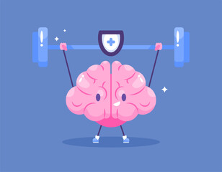

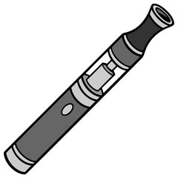

**Young people felt it was important to have someone to talk to stay mentally healthy**.

**Young people enjoyed being online but recognised that it had negative effects on their self-esteem.**

**Young people felt it was positive that there were options outside of GCSE and A-Levels that enabled them to learn skills for the future.**

**Services needed to be more 'young person friendly'**

**Young people felt under pressure to meet expectations, fit in and meet their own goals and expectations.**

**Young people found the youth service helpful but felt there wasn't enough of it**

**What we did next**

We pulled together all the data and information from both young people and key professionals who work with young people. We developed a list of recommendations to share with professionals across the city to support them to continue working together to improve the health and wellbeing of young people in Leeds.

The recommendations suggested:

* ways in which services could be improved for young people
* actions around improving understanding of barriers to education for young people and how educational opportunities could be improved, particularly for young people with SEND and those not in mainstream education.
* there should be a continued focus on improving the mental health of young people, reducing child poverty and increasing opportunities to hear young people’s voice.
* there should be more focus on social isolation and providing opportunities for young people to connect
* there should be services and support to ensure young people have the information to help them be physically and mentally healthy, including support for young parents.
* there should be a continued focus on supporting young people to reduce the impact of harm, including a focus on vaping, drugs, sexual health and sexual violence.

**How will your views help in the future**

* We have made the full Health Needs Assessment available online for anyone to access so they can use the findings to shape services and priority areas of work for young people in the future.
* We will consider key findings when we review our Leeds 0-19 health visiting and school service and other services for young people provided by Public Health.