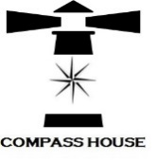

**Compass House Evaluation Report**

**Background**

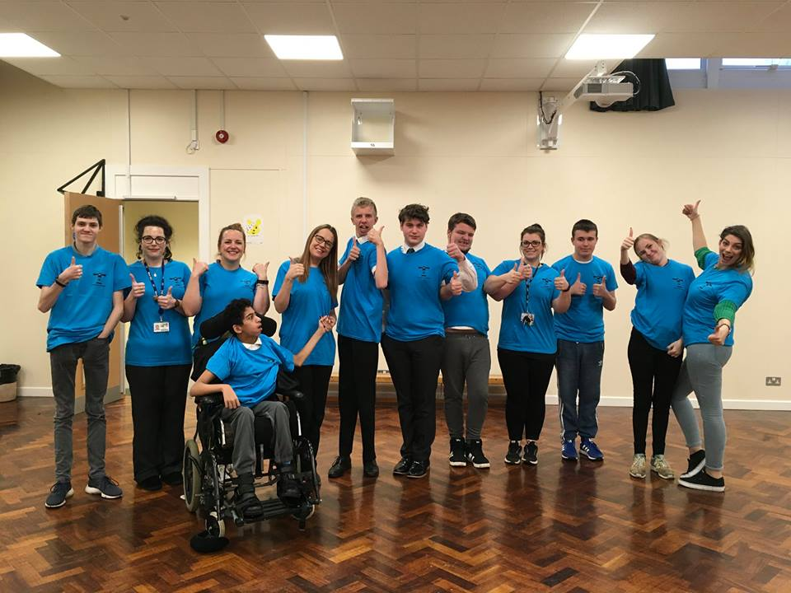In 2017; 102 students from across the SILCs took part in the Mark Your Mark ballot (largest youth consultation in the UK). From the ten issues the students collectively voted that a Curriculum to Prepare us for Life as the top issue for them. Students from West and South SILC tookover the SEND Partnership Boardin November 2017 and spoke to the board about what a curriculum for life means to them.

Following the takeover the VIC team have been working with staff representatives from West SILC, Broomfield South SILC, North West SILC, East SILC and Lighthouse School to address some of the issues raised and ideas suggested in the takeover meeting.

Discussions with staff and students highlighted that work experience is a real barrier within the SILCs. Students with the more complex needs are often unable to get valuable work experience and this results in them doing work experience in their own school setting which isn’t ideal and doesn’t give them an understanding or awareness of work outside the SILC.

**What we did**

In September 2018 a project group made up of staff and student representatives from across the five settings and supported by the Voice, Influence and Change Team was set up to plan a pop up shop. The project group met every other week from the 25th September 2018 to the 5th December 2018. Students made all the decisions around the pop up shop i.e. shop name, colour scheme, products to sell, promotion etc.

Students from across all settings were involved in making the products to sell on the stall.

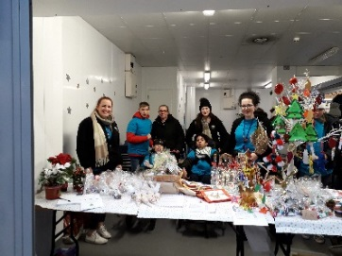‘Compass House’ opened on Monday 10th December till Friday 14th December, 10am till 2pm at a unit within Leeds Kirkgate Market.

Children and Families Service contributed £1080 towards the set up costs and Leeds Kirkgate Market provided the unit free of charge for the week.

**Promotion**

The pop up shop was promoted via social media (@CompassHouseLS on facebook & twitter) as well as flyers being printed and distributed across the settings and organisations.

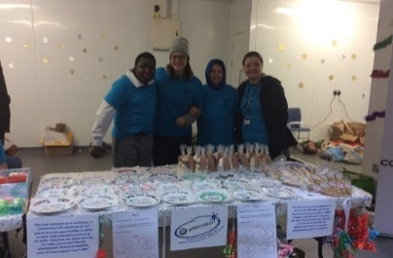

The project group made a [short film](https://youtu.be/cll2bxmw5mg) to promote the shop opening.

A [press release](https://www.google.co.uk/url?sa=i&rct=j&q=&esrc=s&source=images&cd=&ved=2ahUKEwi0nOz6kKngAhVKYlAKHZAVCZwQjhx6BAgBEAM&url=https%3A%2F%2Fnews.leeds.gov.uk%2Fstudents-spread-christmas-cheer-with-compass-house-pop-up-shop-in-kirkgate-market%2F&psig=AOvVaw3KEOo02zPCELXOmruco2NW&ust=1549612066154725) was written and submitted prior to the opening.

**Outcomes**

Compass House was a great youth voice project which enabled staff and students from across the five settings to work in partnership to create a valuable work experience project.

A collective total of £1,565 was raised over the five days.

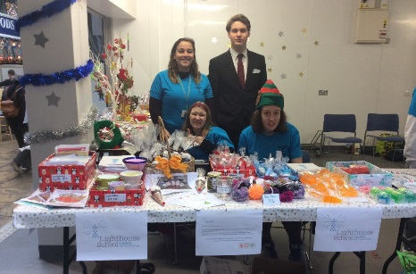 **Highlights and Achievements**

The Compass House project provided students with a unique opportunity to gain meaningful and valuable work experience. During the course of the projects students personal developments were a highlight.

* Working as a team with students from across the settings
* Experiencing Leeds Kirkgate Market
* Socialising with others
* Sense of pride and achievement seeing their handmade products being sold to members of the public
* Increased confidence
* Students took part in a radio interview
* Students took part in a tv interview
* Raised aspirations

As recognition for the commitment to the project, students have been recommended for a Leeds Youth Award.

**Learning**

Compass House will be a long term partnership project that will continue to run twice a year (summer & Christmas). The five settings will work together on the lead up to the pop up shop opening and students from across the settings will be involved in creating products to sell as well as staffing the shop during opening hours.

* 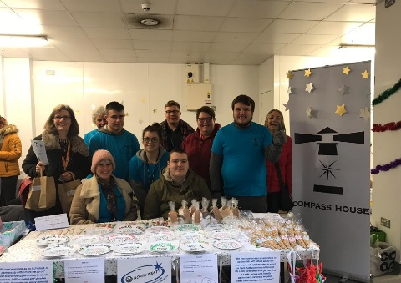Open for three days instead of five (Tuesday to Thursday)
* Students to be involved in the set-up of the shop (Monday)
* Students to be involved in the close down of the shop (Friday)
* Disabled parking to be readily available
* Settings to arrange class visits to the shop
* Consider location of the shop (the market was very cold for students)
* Coordinate prices across settings

|  |  |
| --- | --- |
| **Quotes from young people** | **Quotes from parents / carers** |
| *'It was good working with people from the other SILCs and the Lighthouse School. I have made some new friends.'*  *“I enjoyed myself and enjoyed selling items to people and making money. “*  *“I enjoyed the product line better and thinking of what to make.”* | *“Fabulous creations for a fantastic cause.”*  *“My son loved doing the pop up shop. Thank you so much.”*  *“Brill to see so many young people included.”* |

